Technical Manual

RadPortal

Developed By -
Miracle Advance Technology

Last Update Date -
12/22/2022

This Document Is for the RadPortal Application
Version – 1.1.1

Written By -
S. M. Al Shahaneaz Shaikat

Revision Sheet

Version | Date | Revision Description | Author Name
V 1.1.1 | 21/12/22 | Draft status, Version Controlling, Study Status | S. M. Al Shahaneaz Shaikat
Rev. 2 | DD/MM/YY | Short description of Major changes | Name
Rev. 3 | DD/MM/YY | Short description of Major changes | Name
Rev. 4 | DD/MM/YY | Short description of Major changes | Name

USER'S MANUAL OF RADPORTAL

Table of Contents

1. General Information about RadPortal 5
1.1 System Overview 5
1.2 Project References 6
1.3 Organization of the Manual 6
1.4 Acronyms and Abbreviations 6
1.5 Additional Help 7
2. System Summary 7
2.1 Minimum Hardware Requirements, Supported Browsers List, And Operating System List for RadPortal 7
2.1.1 Hardware Requirements Personal Computers and Laptops 7
2.1.2 Browsers 8
2.1.3 Operating System 8
2.2 User Roles and Permission Levels 8
2.2.1 Service Provider(Admin) 8
2.2.2 Customer 9
2.2.3 Hospitals(Healthcare Service Provider) 9
2.2.4 Radiologist(Subject Matter Experts) 9
2.2.5 Viewer 9
3. Getting Started 10
3.1 Logging In 11
3.2 System Menus 15
3.3 How to Change Password, Change Profile Picture, and Add Your Digital Signature 16
3.3.1 Changing Password 16
3.3.2 Changing Profile Photo 18
3.3.3 Adding Digital Signature 19
3.4 Software Version and Updates 20
3.5 Sign Out from The System 21
4. Exploring Worklist Menu 22
4.1 How to Search Studies 23
4.2 How to Sort Studies 24
4.3 How Study information is Organized In Study worklist 25
4.4 How to Review Images, Resend To PACS, Cancel, Edit, View Report and Attach Additional Documents to Studies 27
4.4.1 Review Images of a Specific Study 28
4.4.2 Resend to PACS (Picture archiving and communication system) 30
4.4.3 Cancel (Remove) Studies 30
4.4.4 Reconcile Studies 31
4.4.5 How to Submit Study/Case 33
4.4.6 View Study Reports 34
4.4.7 Attach Additional Files To A Study 35
4.6 How to Submit Studies 37
4.7 How to Assign a Radiologist to a Case/Study 41
5. Registration Menu 43
6. User list 45
6.1 How to Add New Users 46
6.2 How to Approve and Update User Information 48
6.3 How to Organize Information of Users 49
7. Organization Setup 52
7.1 How to Add New Organization 52
7.2 How to Update Organization Information 55

1. General Information about RadPortal

Radportal is a Secured cloud-based radiology platform. The main problem it solves is that there are many hospitals in remote places worldwide with all the modern medical equipment for medical tests such as (MRI, CT scan, x-rays, nuclear medicine, ultrasound, and more). Still, hospitals may not have expert radiologists/doctors readily available to write the reports for these studies when patients come to these remote hospitals and complete their tests.
Sometimes the Patient has to physically go to hospitals/Other more developed cities where radiologists/Doctors are available, but this process is difficult and time-consuming.
Using the RadPortal System, the hospital can easily save patient test results. Then the hospitals can forward the test results to an expert doctor/radiologist who may not live nearby.

System Overview
RadPortal is a secured cloud-based radiology platform. It helps hospitals to send their Patient's radiology test images to doctors/radiologists worldwide and receive written reports from remote doctors/radiologists.
RadPortals Core functionalities are
- All hospitals/sites that have already configured modality devices can automatically send DICOM files to their routers, which are then forwarded to the RadPortal cloud database.

- RadPortal system reads the DICOM headers and collects information from the header, and saves it as an entity called "study".

- Hospitals also can upload single or multiple DICOM files manually.

- Hospitals can then access DICOMs from their RadPortal profiles and assign specific radiologists to write reports on that particular study or keep the study open for other radiologists.

- Suppose any open study is available on RadPortal. In that case, the independent radiologists can log in to their RadPortal profiles and independently select any open study. Then the individual Radiologist can write reports for that particular study.

- The Radiologist has a roaming profile, so they do not need specific devices to interact with the RadPortal system. The Radiologist can interact with the RadPortal system with laptops, desktops, or tabs and a reliable Internet connection.

- RadPortal also helps Government Institutes such as the National Health Security office to track the number of studies and reports the hospitals and the radiologists completed and disburse fees and payments accordingly.

Project References
References used in preparing this document are listed here. Project References may help you understand the complex topics and terms used in the RadPortal system.

http://dicomlookup.com/modalities.asp

1.3 Organization of the Manual
This document is patterned to familiarize you with the core functionalities of the RadPortal application. This document explains how the application is intended to use by properly explaining its functionalities and limitations.
You will also know how the RadPortal application saves information and how the information is shared across multiple user roles within the RadPortal system. We will discuss the most common elements so readers can later relate to the terms as they look deeper into the application's features and functionalities.
The functionalities will vary depending on user roles, but the role Admin will have access to all the functionalities of RadPortal. User roles are extensively explained in section 2.2, User Roles and Permission Levels.

1.4 Acronyms and Abbreviations
Common acronyms and abbreviations are introduced in this section so the reader can get comfortable with the acronyms and abbreviations used in this documentation and the RadPortal application.
DICOM Digital Imaging and Communications in Medicine.
PACS Picture archiving and communication system.

1.5 Additional Help
Common terms are introduced throughout the user manual to familiarize the reader with the common terms used in the application. Sections are indexed(numbered, bullet points, and roman numbers). Sections are also linked to common keywords so the reader can go directly to any relevant section to find more information. For easier navigation, keywords are marked in blue.
Here are the styles used for lists
Bulleted lists:
- Text 1
- Text 2
- Text 3
Numerical numbered lists:
- Text 1
- Text 2
- Text 3
Roman numbered lists:
- Text 1
- Text 2
- Text 3

Here are the styles for Notes and warnings.
Note: Notes are marked in the color blue.

Warning: Warning messages are marked in the color red.

2. System Summary

2.1 Minimum Hardware Requirements, Supported Browsers List, And Operating System List for RadPortal

2.1.1 Hardware Requirements Personal Computers and Laptops
Processor (CPU) with 2 gigahertz (GHz) frequency or above
- A minimum of 2 GB of RAM
- Monitor Resolution 1024 X 768 or higher

- A minimum of 20 GB of available space on the hard disk
- Internet Connection Broadband (high-speed) Internet connection with a speed of 4 Mbps or higher
- Keyboard and mouse or compatible pointing device

2.1.2 Browsers
- Chrome 36+
- Edge 20+
- Mozilla Firefox 31+
- Internet Explorer 11+ (Windows only)
- Safari 6+ (macOS only)

2.1.3 Operating System
- Windows 7, Windows 8, Windows 10, or Windows 11
- Mac OSX 10.8, 10.9, 10.10, or 10.11

2.2 User Roles and Permission Levels
Before we look deeper into the RadPortal system, you must understand the user roles properly. The user roles are listed below.
- Service Provider(Admin)
- Customer
- Hospitals(Healthcare Service Provider)
- Radiologist(Subject Matter Experts)
- Viewer

2.2.1 Service Provider(Admin)
Miracle Advance Technology is the service provider, and Miracle Advance Technology plays the Administration role inside the RadPortal System. The main functionality of an administrator role is to manage the system so that the system runs smoothly and without errors. For the RadPortal system, the Service Provider will also install, configure and manage DICOM routers for the healthcare service provider.

2.2.2 Customer
This role is very important in the RadPortal system. The only customer role can Configure Turnaround Time, Assign radiologists to a study and manage and verify Radiologists. They also have full control over the RadPortal system. The Customer is also in charge of disbursing Fees and payments to the Hospitals and Radiologists.

2.2.3 Hospitals(Healthcare Service Provider)
Hospitals are also called "sites" in the RadPortal system. Hospitals play an significant role in the RadPortal System. They have to perform medical tests such as (MRI, CT scan, x-rays, nuclear medicine, ultrasound, and more) and manually upload files and images from browsers or the modality devices can automatically send DICOM files to RadPortal servers to create cases which are also called studies. The hospital can access the files, images, and DICOMs uploaded to the RadPortal server.

2.2.4 Radiologist(Subject Matter Experts)
The Radiologist also plays a significant role in the RadPortal System. There are two types of radiologist roles in the RadPortal system.
- Normal Radiologists
- Supervisor Radiologist
The main difference between the Supervisor and a normal Radiologist is that a Supervisor Radiologist can view all cases or studies. A normal radiologist can only see the studies/cases they are assigned to or any studies that are kept open for radiologists. Only the verified normal Radiologist can write reports of submitted studies/cases.

2.2.5 Viewer
The Viewer role is a bit unique. The viewer does not interact with any aspects of the RadPortal system. The viewers only view how many cases/studies the hospital/sites completed and how many reports the radiologists submitted and finalized in the RadPortal system.
This role is given to people with authority to monitor and audit the RadPortal system. This role is also given to the government institutes that might want to monitor the whole RadPortal system.

3. Getting Started
Before using the RadPortal system, you have to log in to the RadPortal system.
To log in, you have to go to this URL – https://app.radportal.net/#/login. After the login page properly loads, you should see a page like this
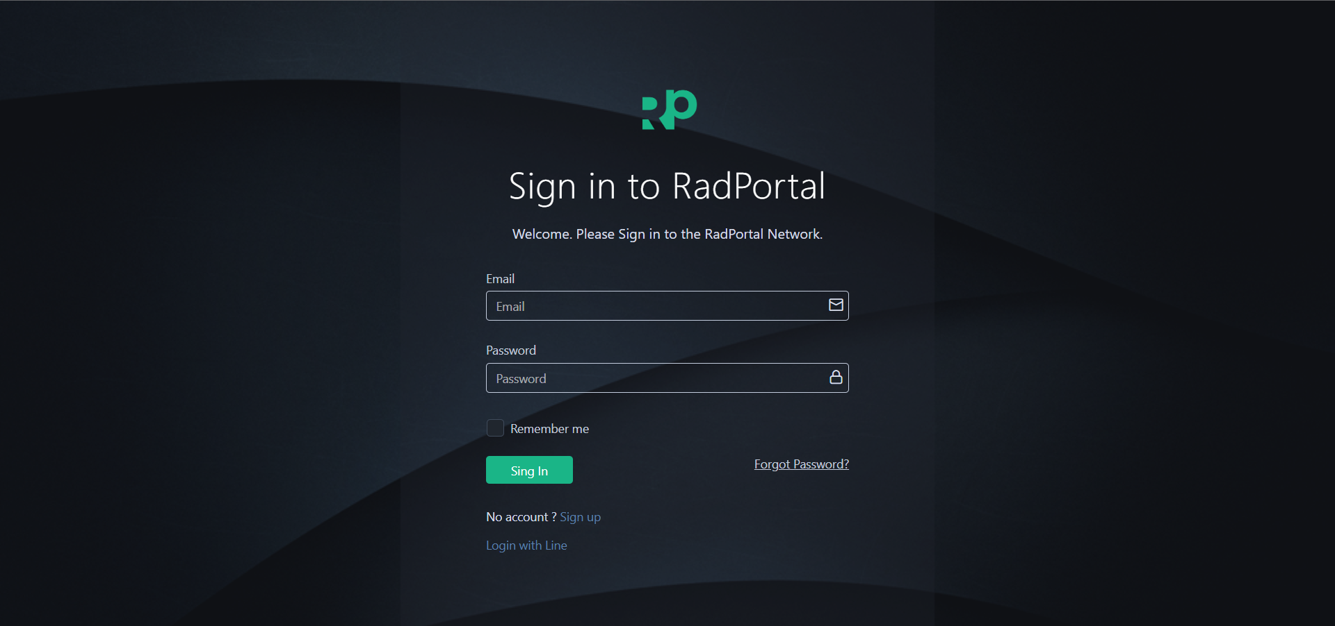

3.1 Logging In
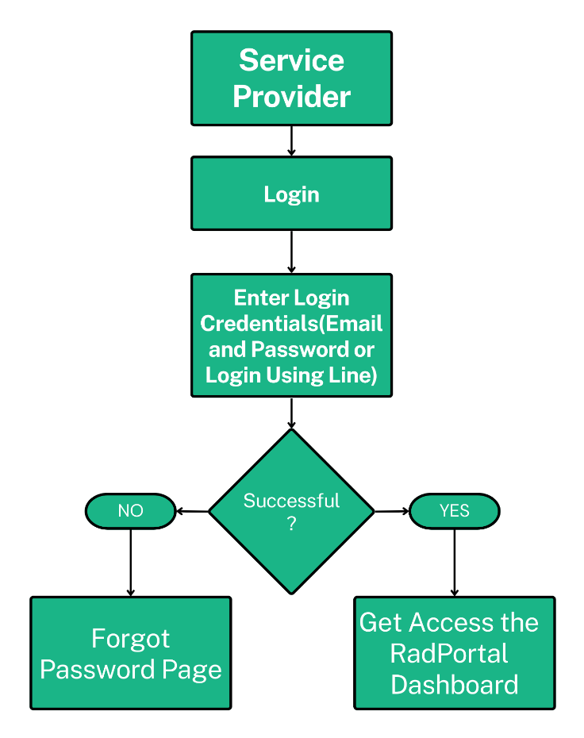
This workflow diagram shows you the login process of the Service Provider (Admin)

After you access the login page, you can use your Email [1] and Password [2] to log in to the RadPortal. You have to use the login credentials you used to create your account. Finally, click on the Sign In [3] button.
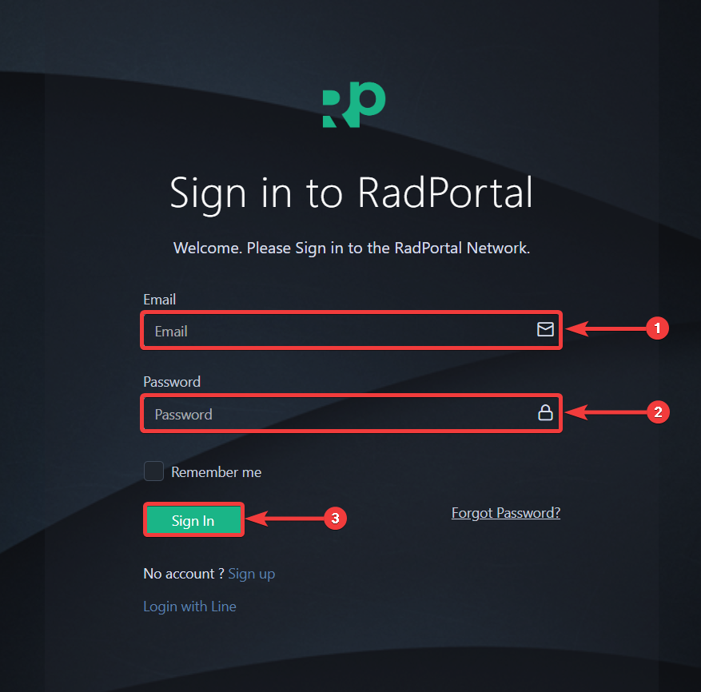

If you can not remember your Password, you can reset your Password.
To reset your Password, you have to click on the Forgot Password? Text.
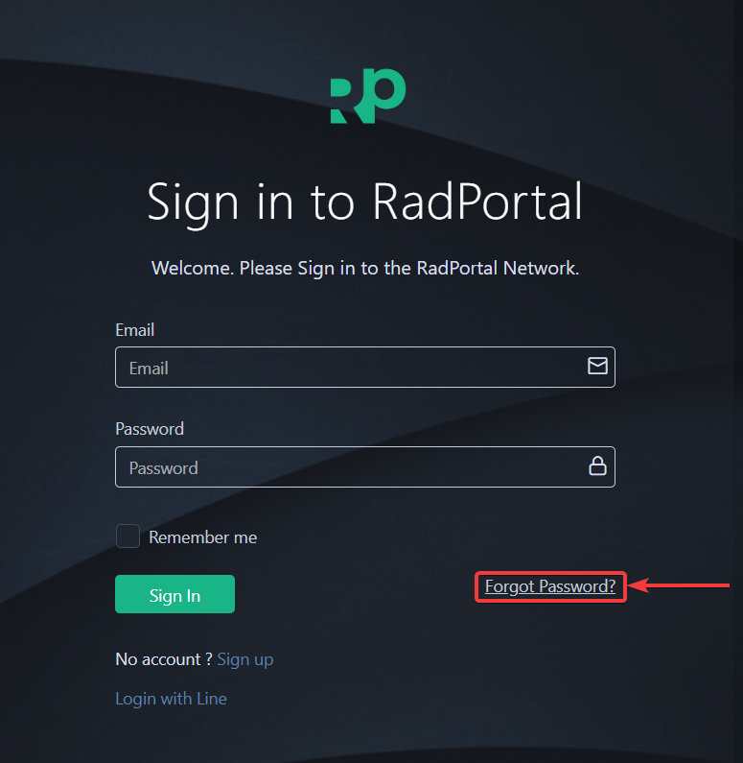

After clicking, the system will take you to the forgot password page. The forgot password Page should look like this
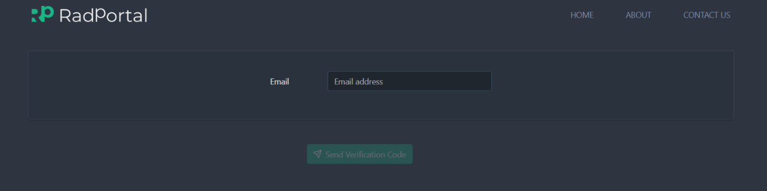
Now, insert your Email and click on Send verification Code.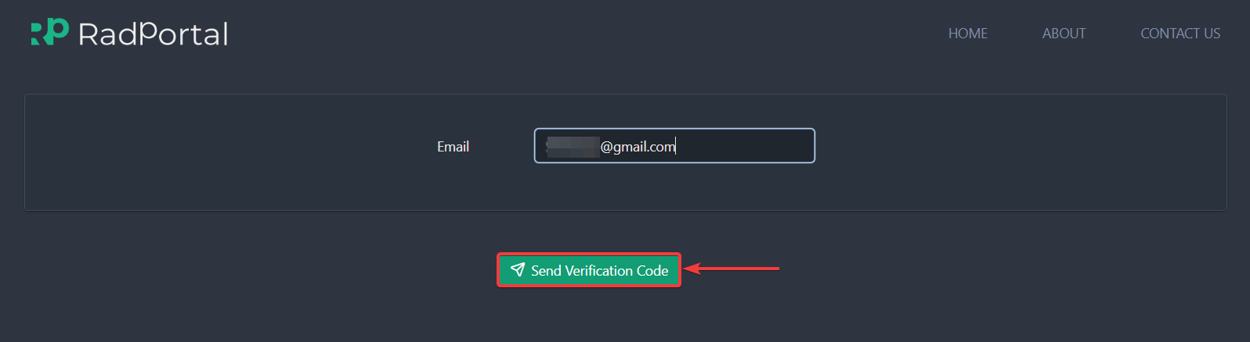

After clicking, you should see a Type code field [1] popup under the email field where you have to insert the OTP (One Time Password). You should receive the OTP code in your mail. After inserting the OTP code, click on the Confirm [2] button.
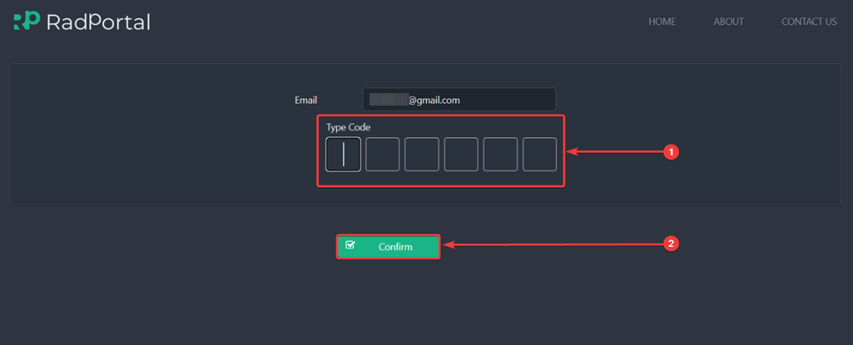

After clicking, you will be presented with two new fields where you have to insert your new Password and click on the Conform button. Now you can log in to the RadPortal system with your new Password.
After successfully logging in, you should see the dashboard of the RadPortal system.
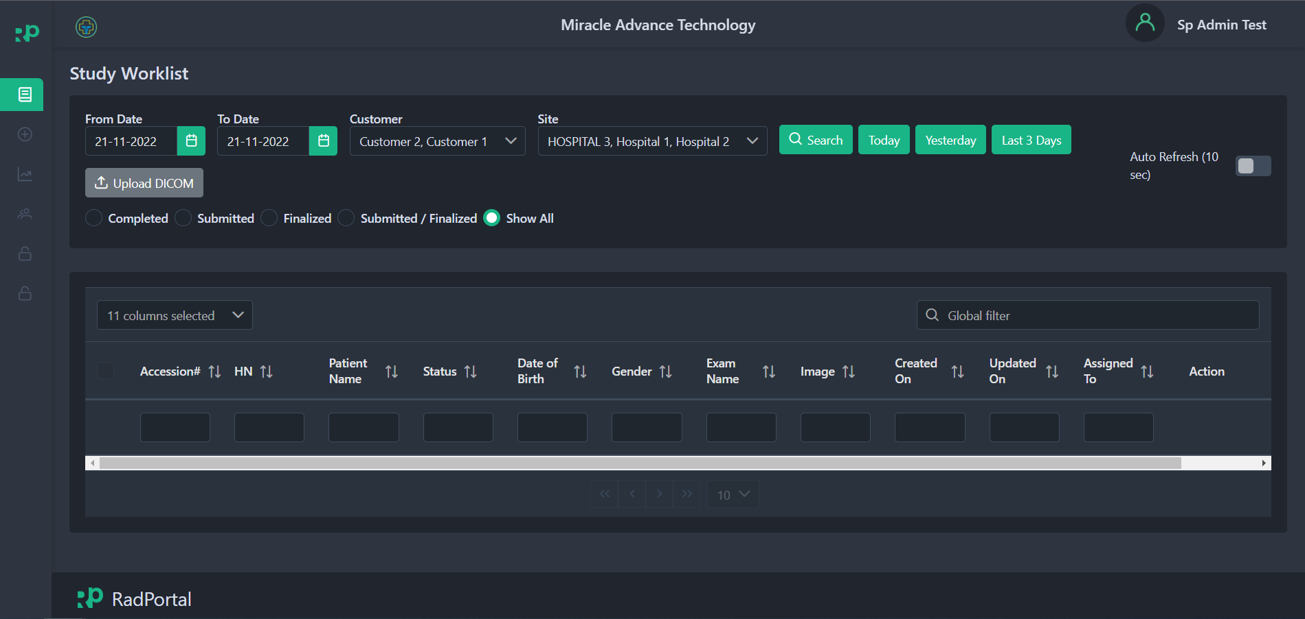

System Menus
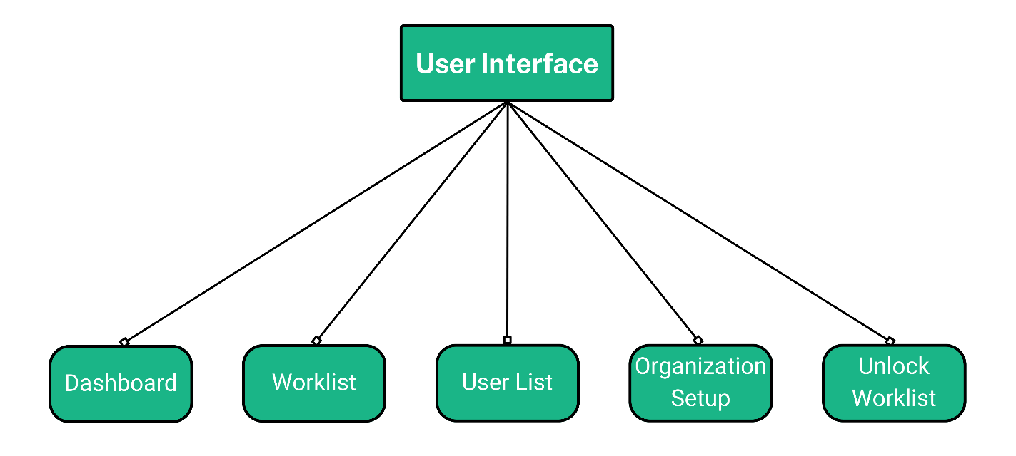
The RadPortal system has these menus currently available
- Dashboard
- Worklist
- User List
- Organization Setup
- Unlock Worklist

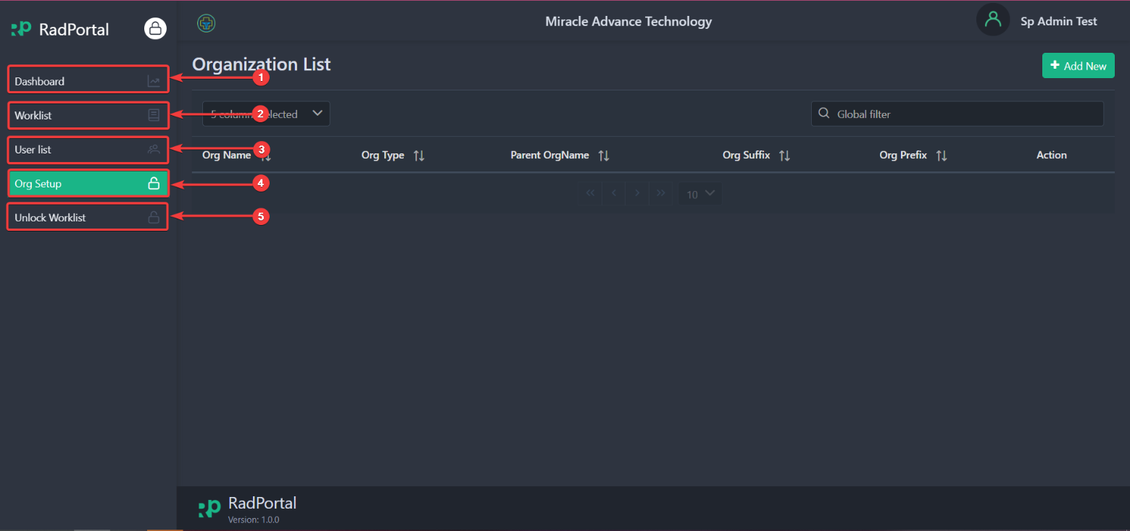

How to Change Password, Change Profile Picture, and Add Your Digital Signature

3.3.1 Changing Password
You can easily change your RadPortal login password from your profile. To access your profile, click on your username [1] in the top right corner and click on Profile [2].
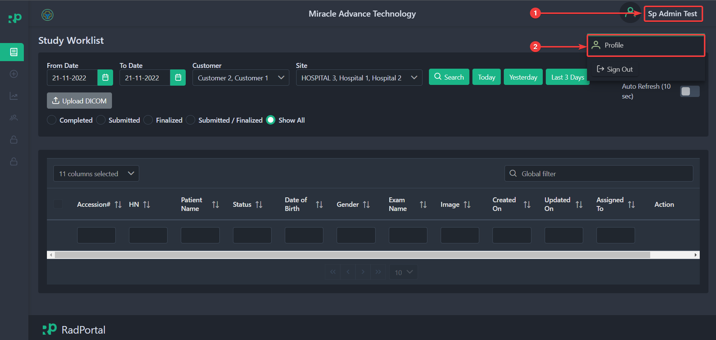

After clicking on The Profile, the system will redirect you to your profile page. On this page, you can change your Password. To change your user Password, click on the Change User Password button.
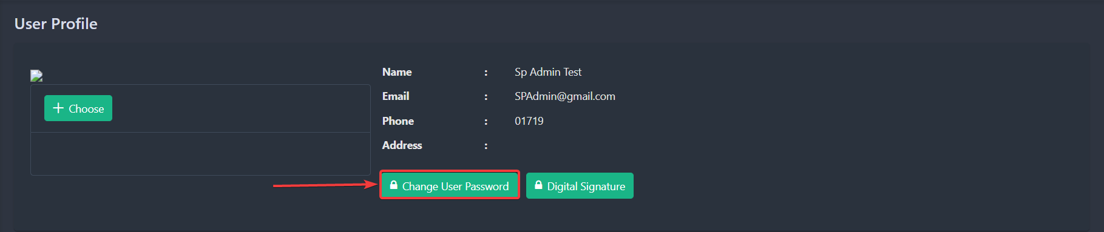

After clicking, you should see a new page where you have to confirm your Old Password [1], enter your New Password [2], and confirm your new Password [3]. Click on the Update button [4] to finalize your new password setup.
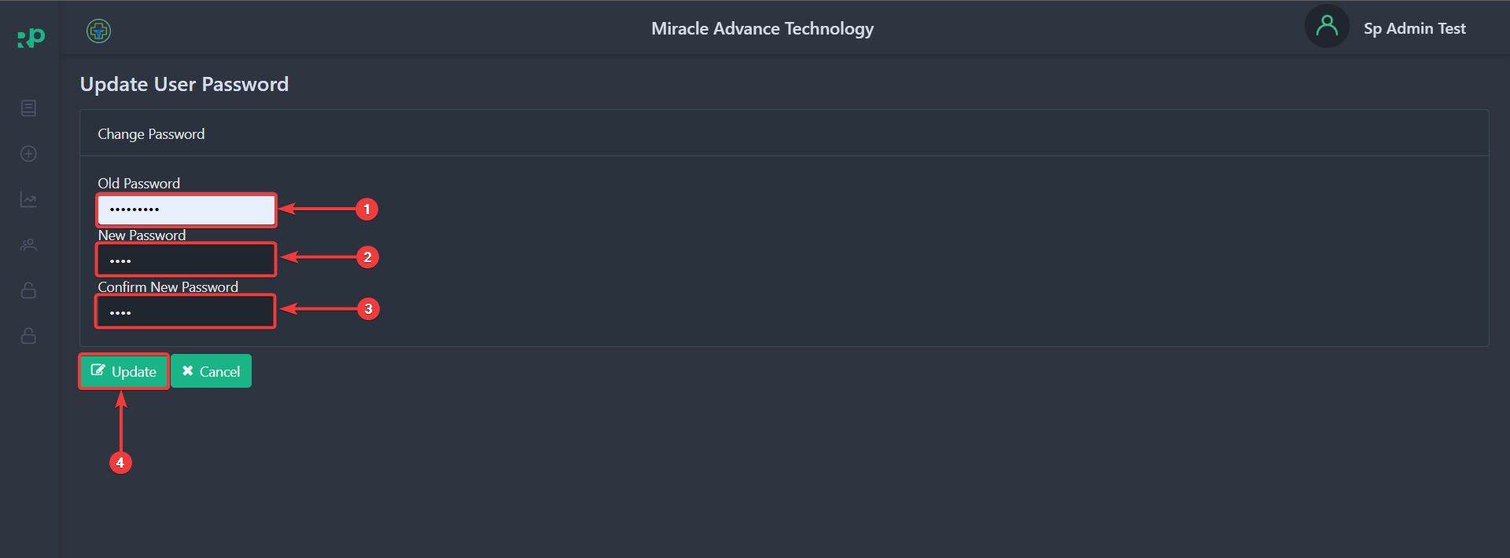

3.3.2 Changing Profile Photo
To change your profile photo, go back to your profile again and click on the Choose button.
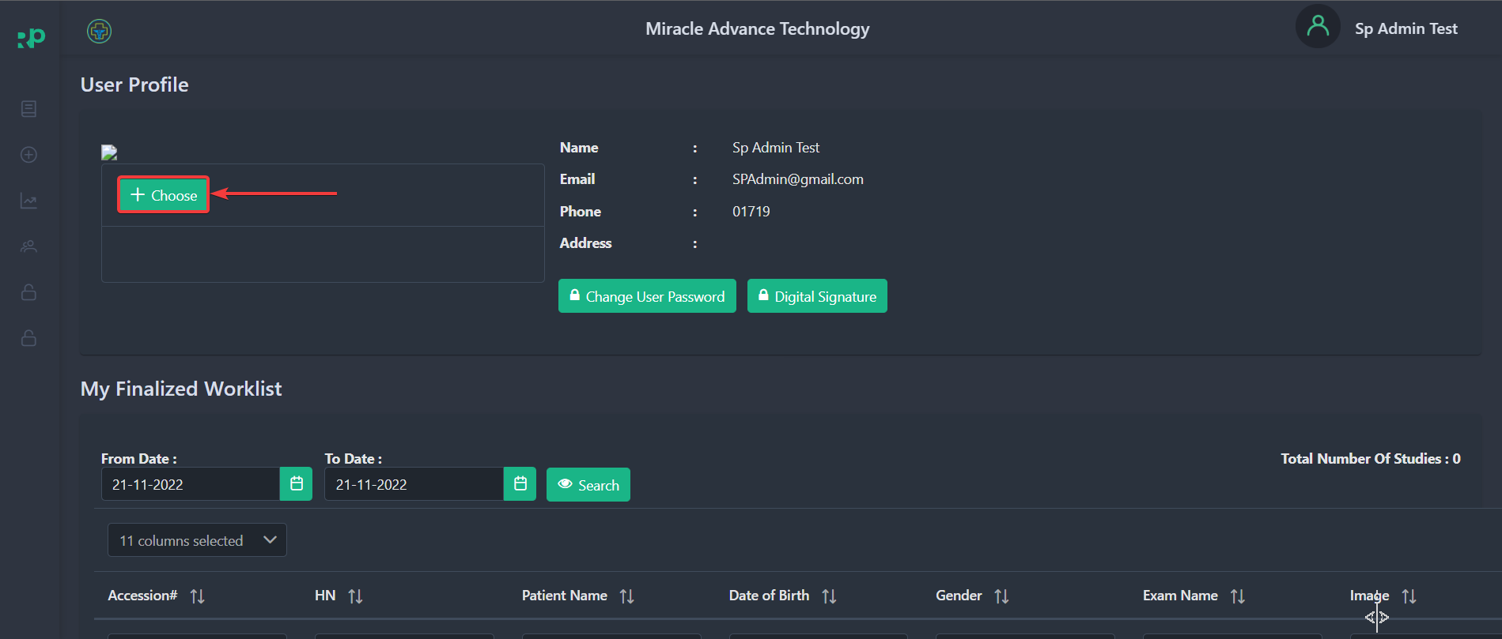

After clicking on the button, you can choose a photo for your profile. You can select your photos directly from your computer. After you upload your profile photo, you will see the preview in the section below.
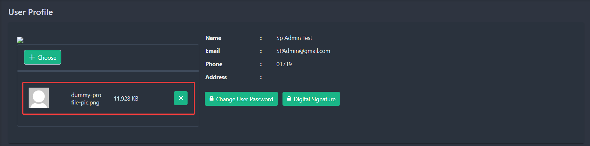

You can remove the photo by clicking on the green cross Icon.
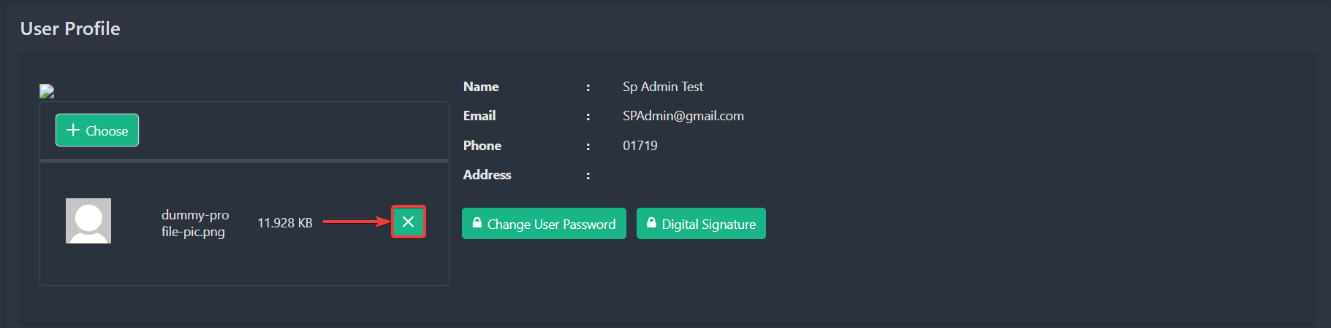

3.3.3 Adding Digital Signature
To add your Digital Signature, go back to your profile and click the Digital Signature button.
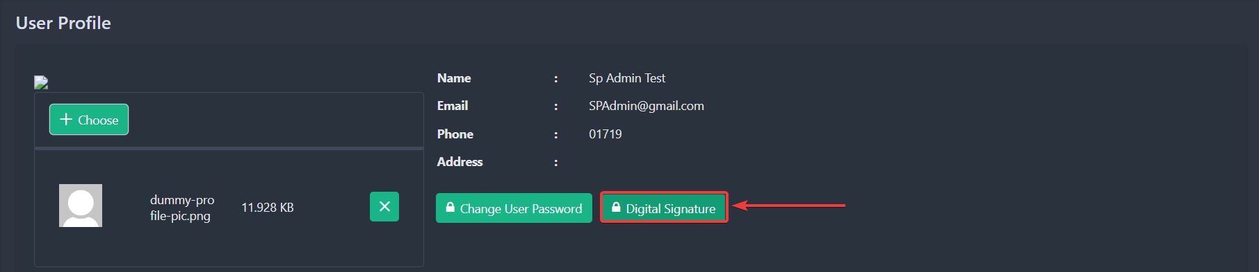

After clicking, you should see a new page where you will be able to upload your digital signature
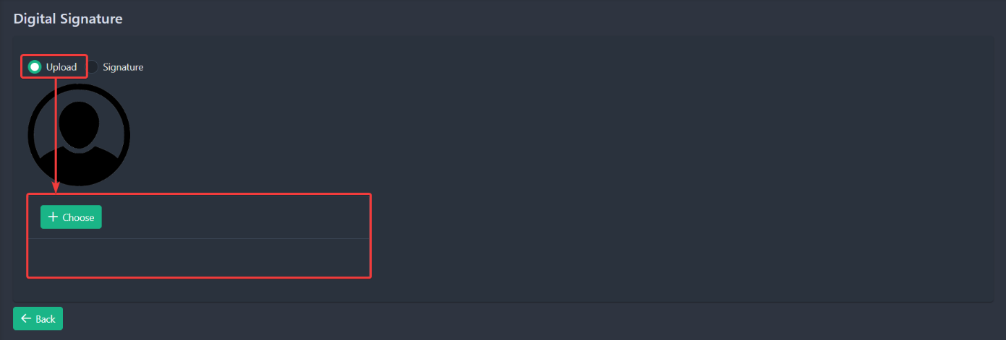

Or you can directly sign on the white blank section.
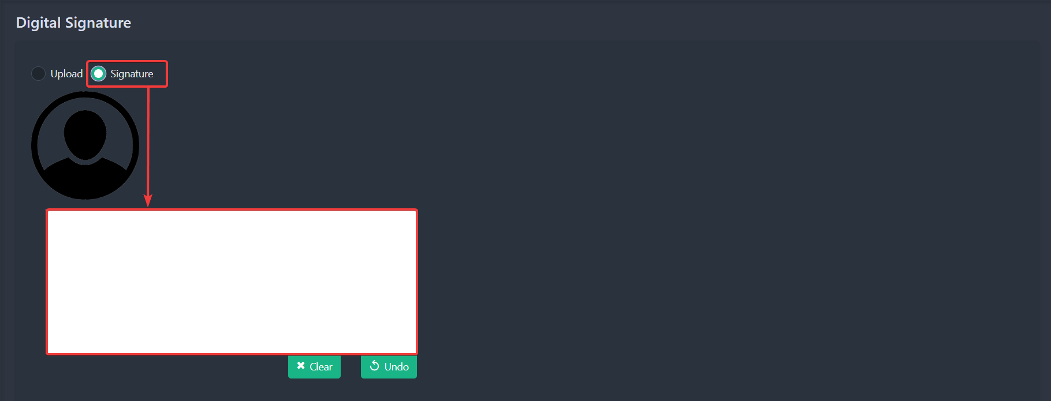

You can Clear your signature or undo a specific part of the signature by clicking on the Clear or Undo Button.

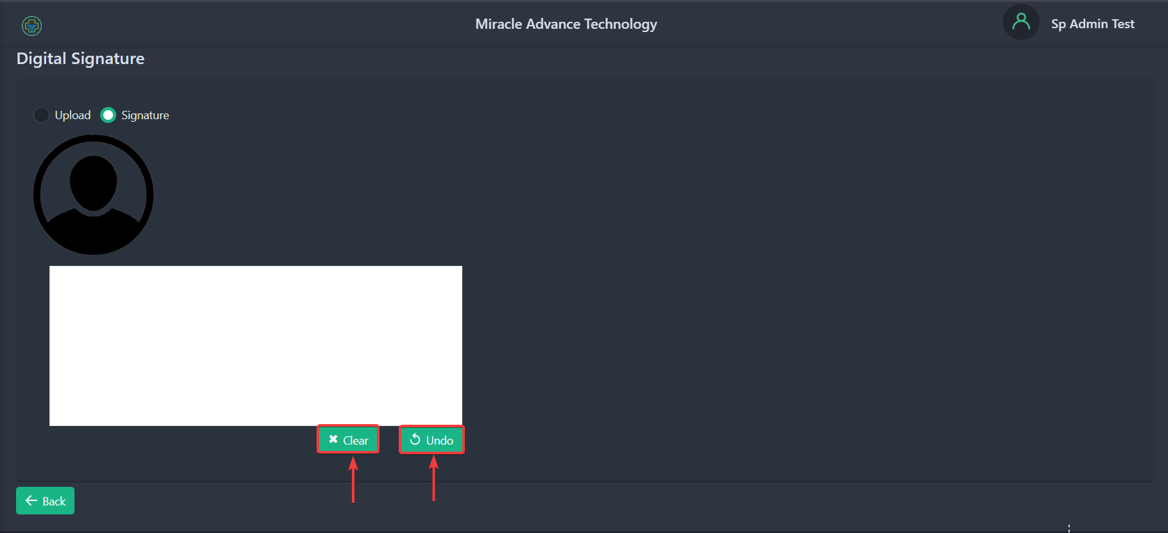

3.4 Software Version and Updates
You can check The RadPortal version in the footer of the RadPortal website. The latest Radportal version is 1.0.0
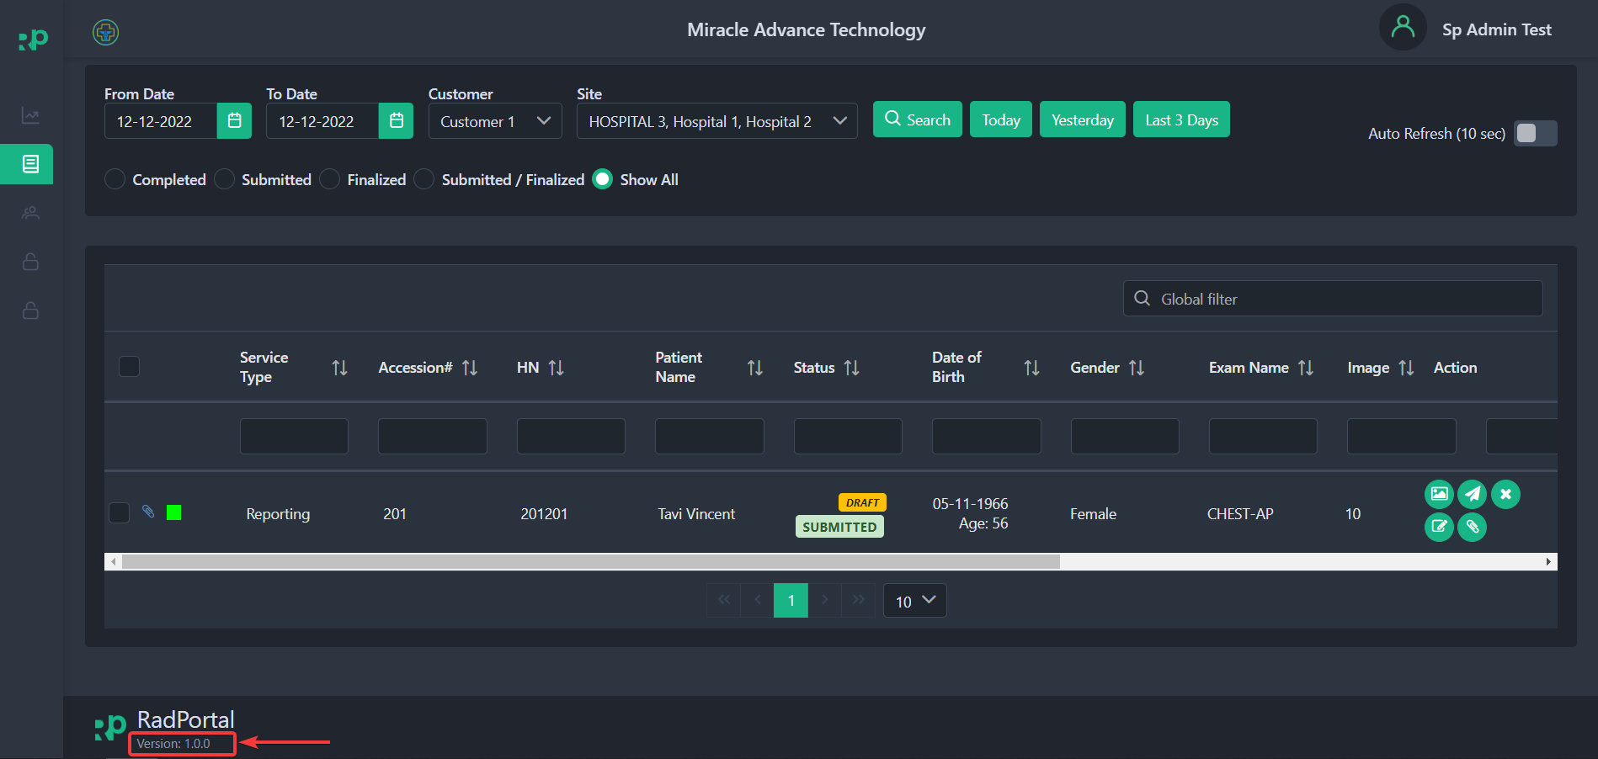

3.5 Sign Out from The System
To Sign Out from the RadPortal system, click on your username [1] in the top right corner and click on Sign Out [2].

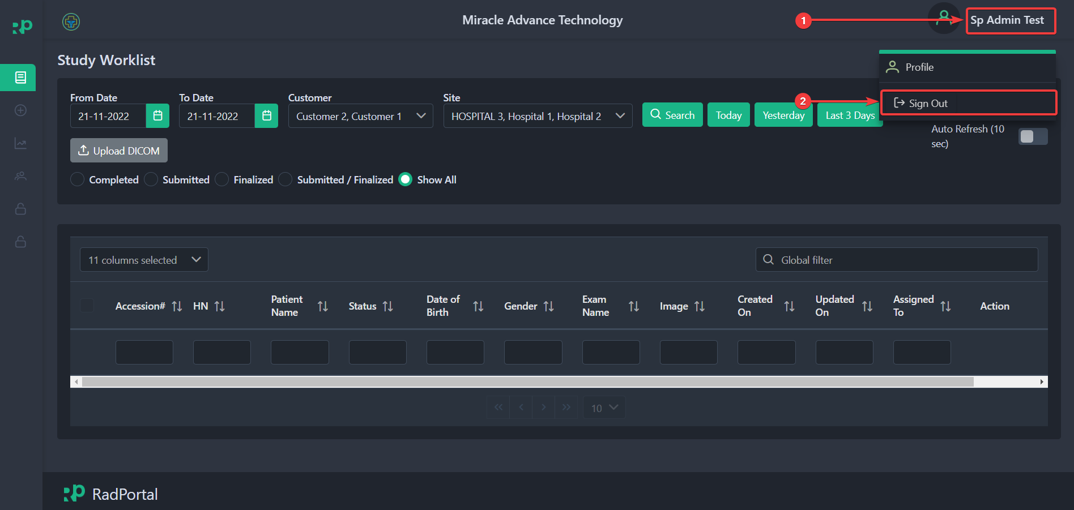

4. Exploring Worklist Menu
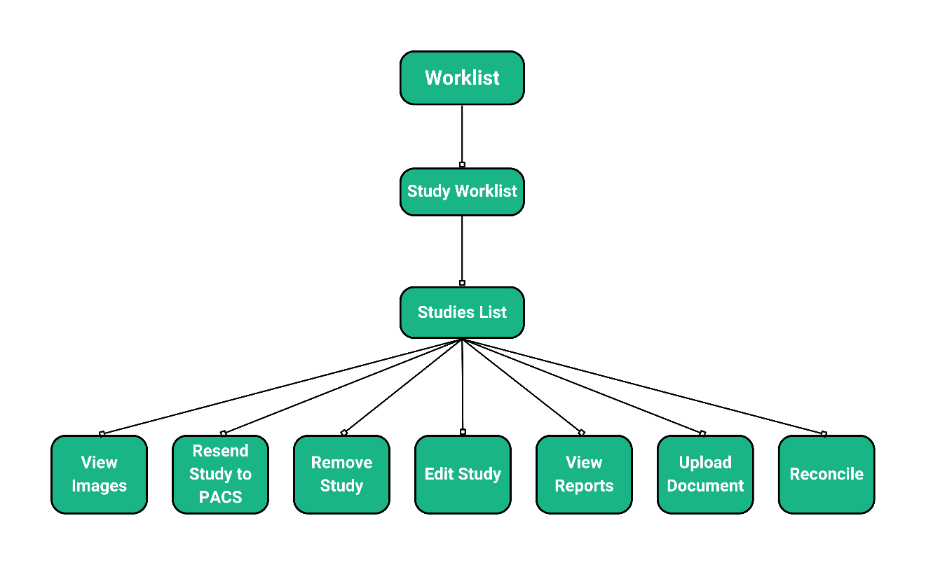

This menu in the RadPortal system allows you to keep track of all New, Submitted, and Finalized studies, or you can search for studies based on custom criteria. Using this Worklist Menu, the hospitals and the admin groups can Upload DICOM files manually. The worklist Menu page should look like the screenshot below.
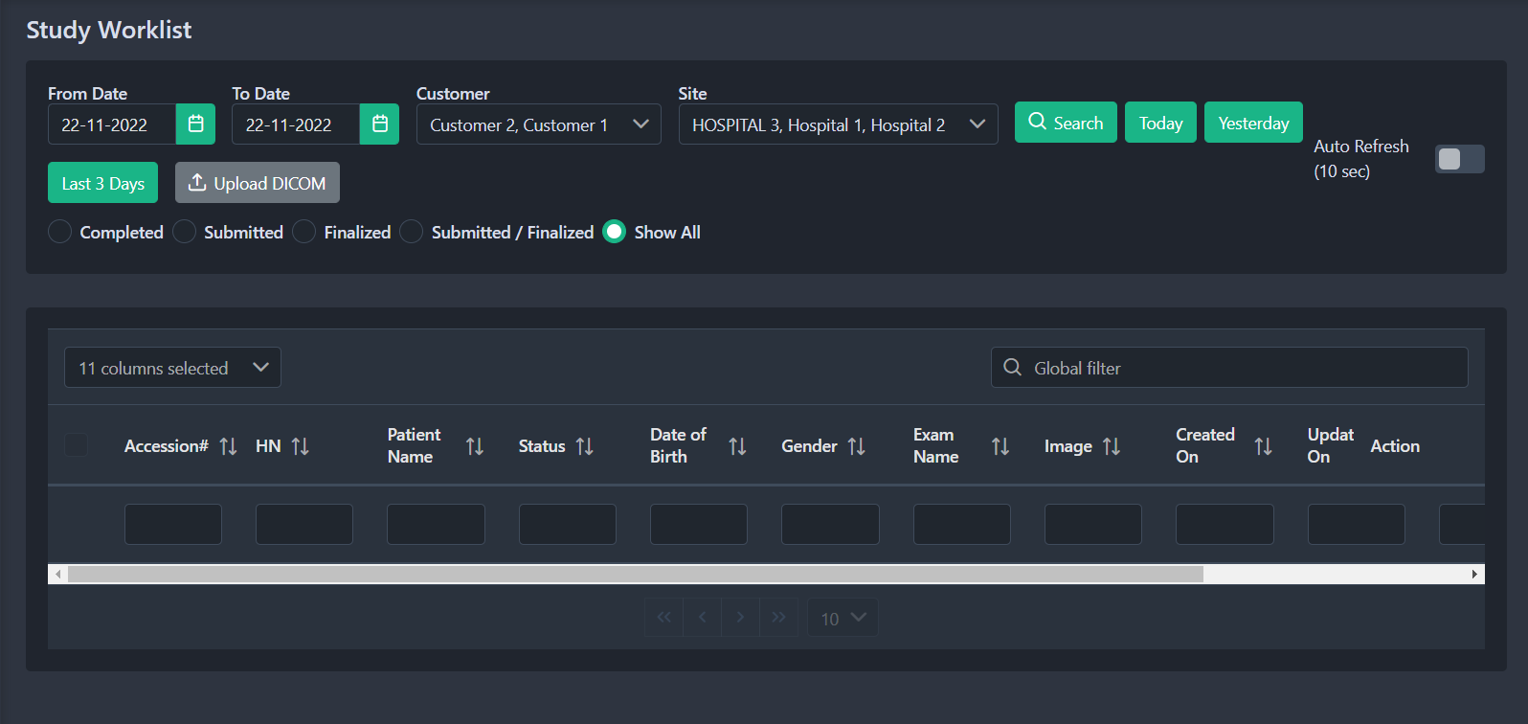

4.1 How to Search Studies
You can custom search based on criteria such as From Date [1], To Date [2], or search based on the specific Customer by selecting a customer [3], or you can also search by selecting a specific Site or Hospital [4]. Finally, click on the Search [5] button.
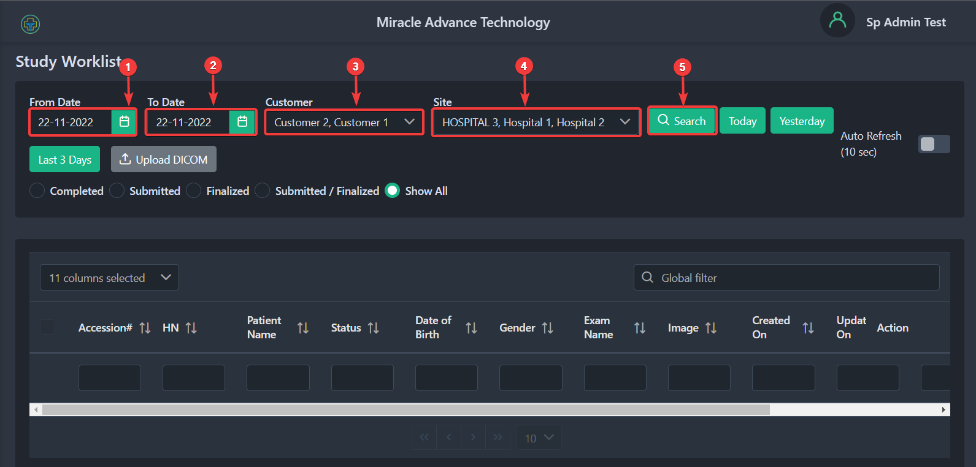

After clicking, you should see all studies/cases that match your custom criteria.
You can even see all studies/cases created Today [1], Yesterday [2], or in the last 3 days [3].
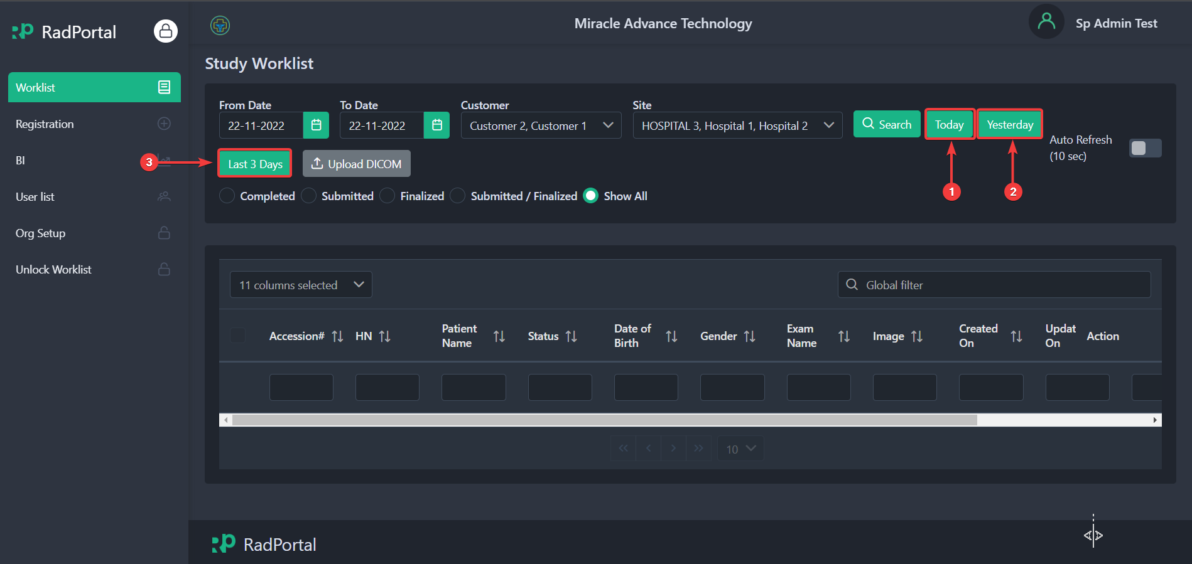

4.2 How to Sort Studies
You can easily sort study-list based on status, such as Completed [1], Submitted [2], Finalized [3], or both Submitted and Finalized [4]. To sort studies, just click on the radio button you see before each status section.
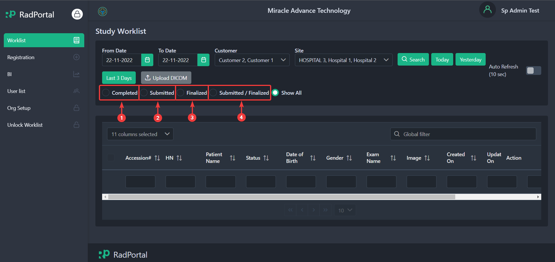

Or you can view all studies by clicking on the Radio Button you see before Show All text.
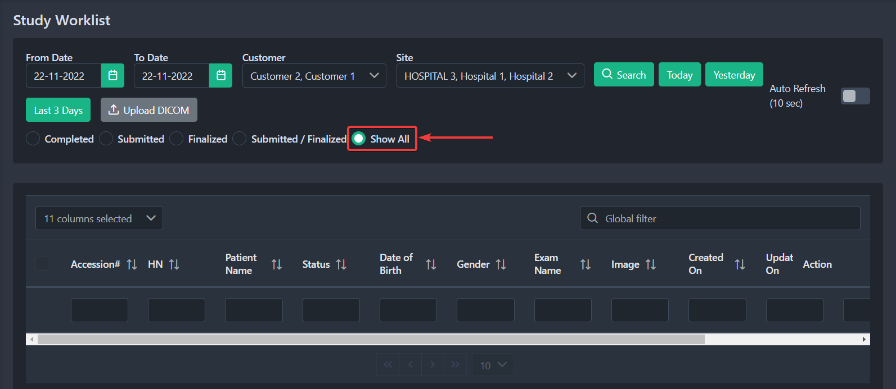

You can enable auto-refresh by clicking on the auto-refresh slide button. After enabling auto-refresh, the page will refresh continuously after every 10 seconds.
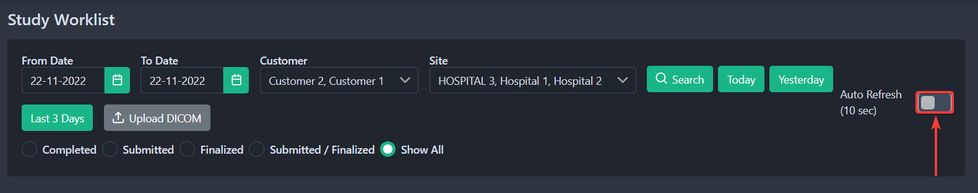

4.3 How Study information is Organized In Study worklist
Currently, there are 13 information types on the study worklist page, such as:
- Service Type: It shows the service type of a specific study.
- Accession Number: It is a unique identifier of a study for the RadPortal system.
- HN (Hospital Number): is a unique identifier generated on the hospital end.
- Patient Name: It shows the patient's Name.
- Status: It shows the status of a particular case/study.
- Date of Birth: Shows the patient's Date of birth.
- Gender: Show the patient's gender.
- Exam Name: It shows the exam name of a case/study
- Image: It shows the total image count of a specific study.
- Created On: It shows the creation date and time of a particular case/study.
- Updated On: It shows the last update date of a particular case/study.
- Assign To: It shows the Name of a radiologist assigned to a particular case/study.
- Modality: It shows the test code (this code is collected from the DICOM Header) of a particular case/study.

To activate an information type, click on Choose Columns [1] and find the information type you want to activate. To activate, click on the Checkbox [2] before the information type.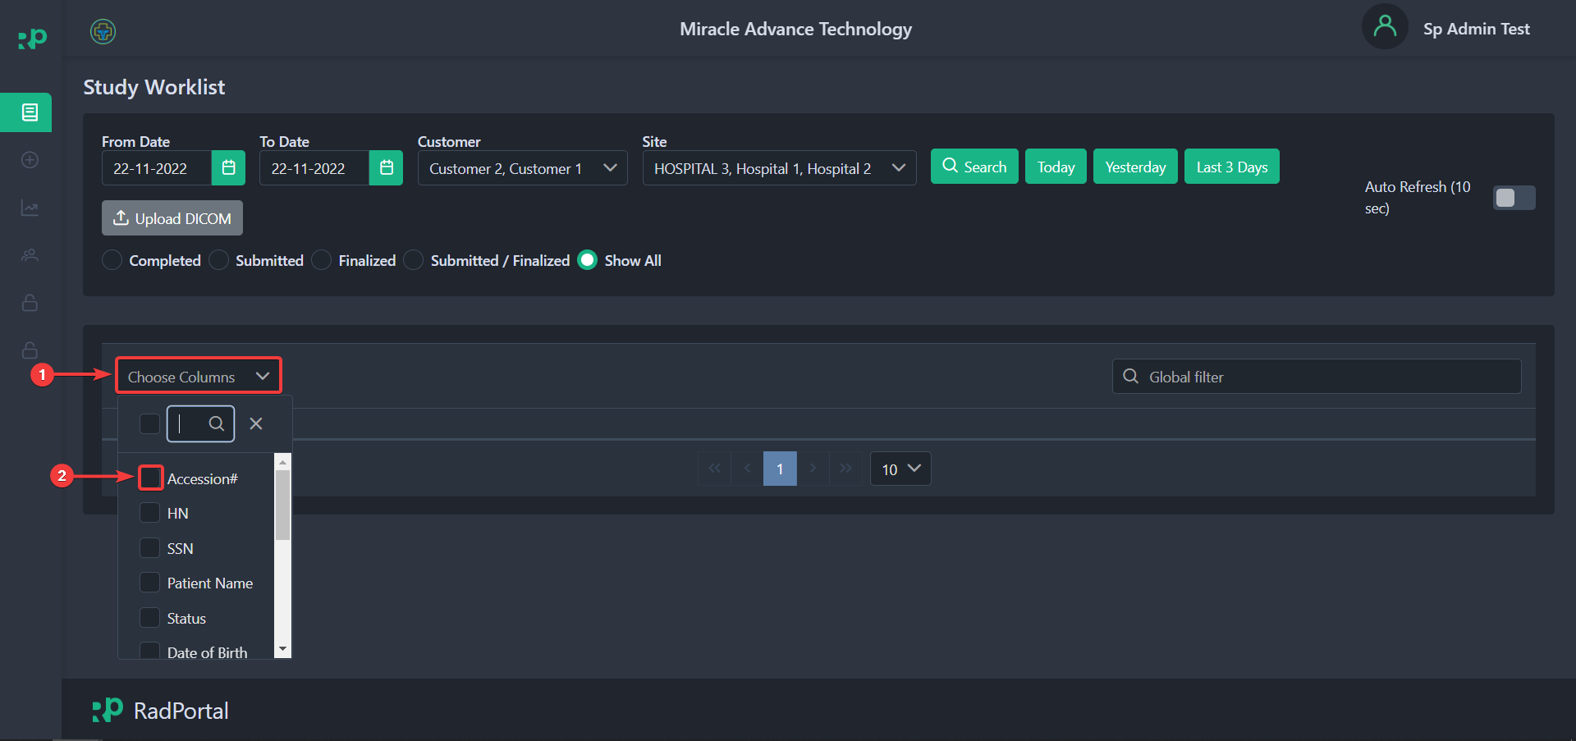

After selecting, you should see that the specific information type is now activated.
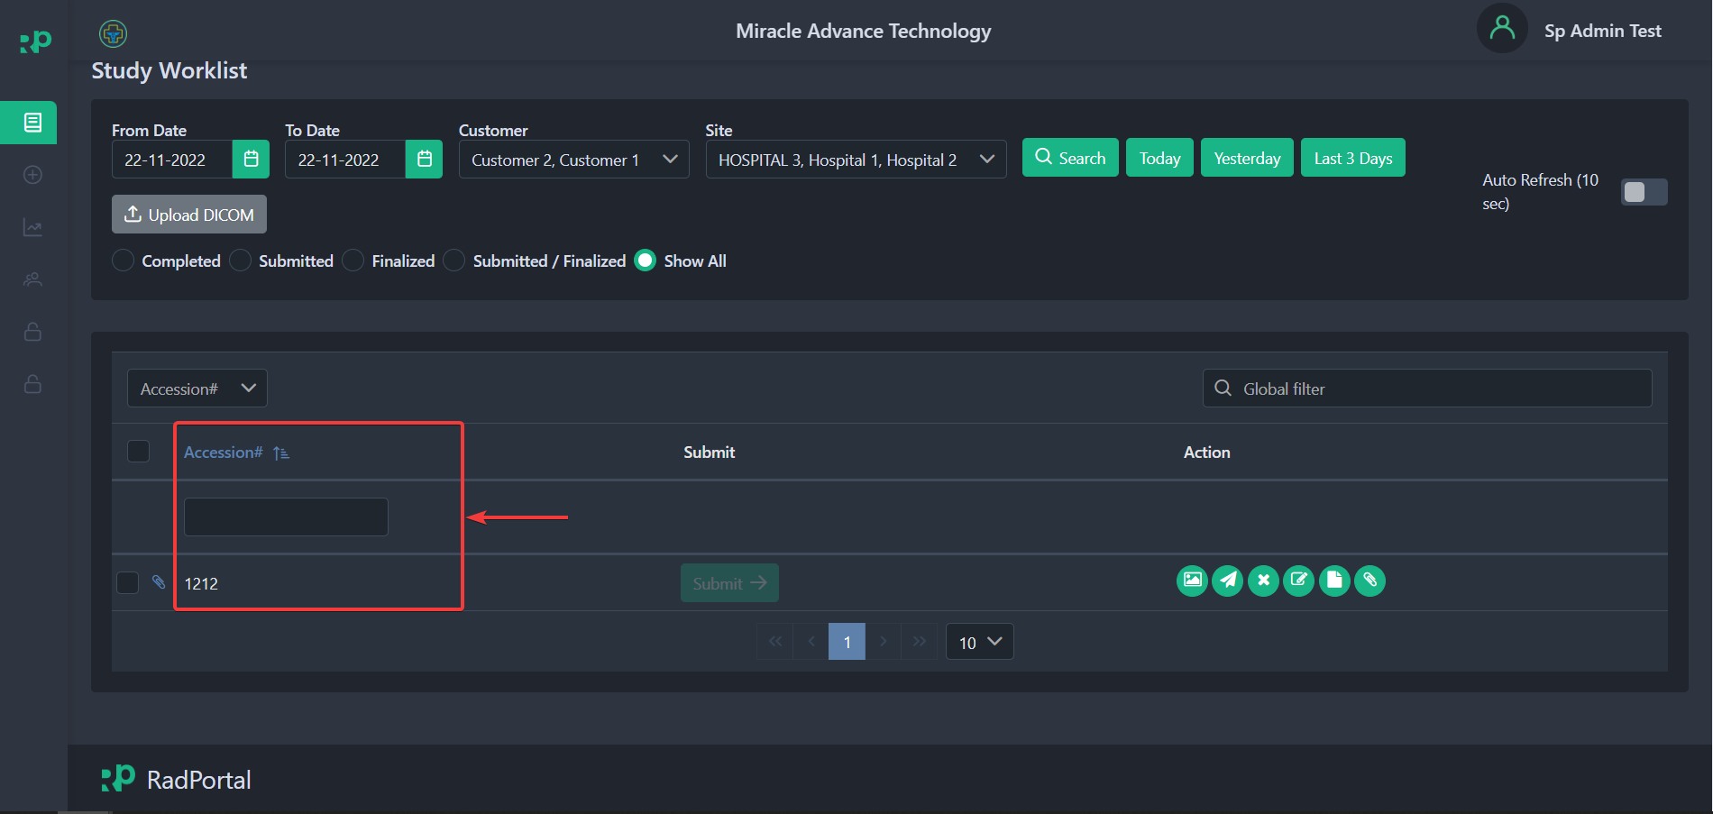

You can activate all information types by clicking on Choose Columns [1] and then clicking on Checkbox [2] at the top of the dropdown.
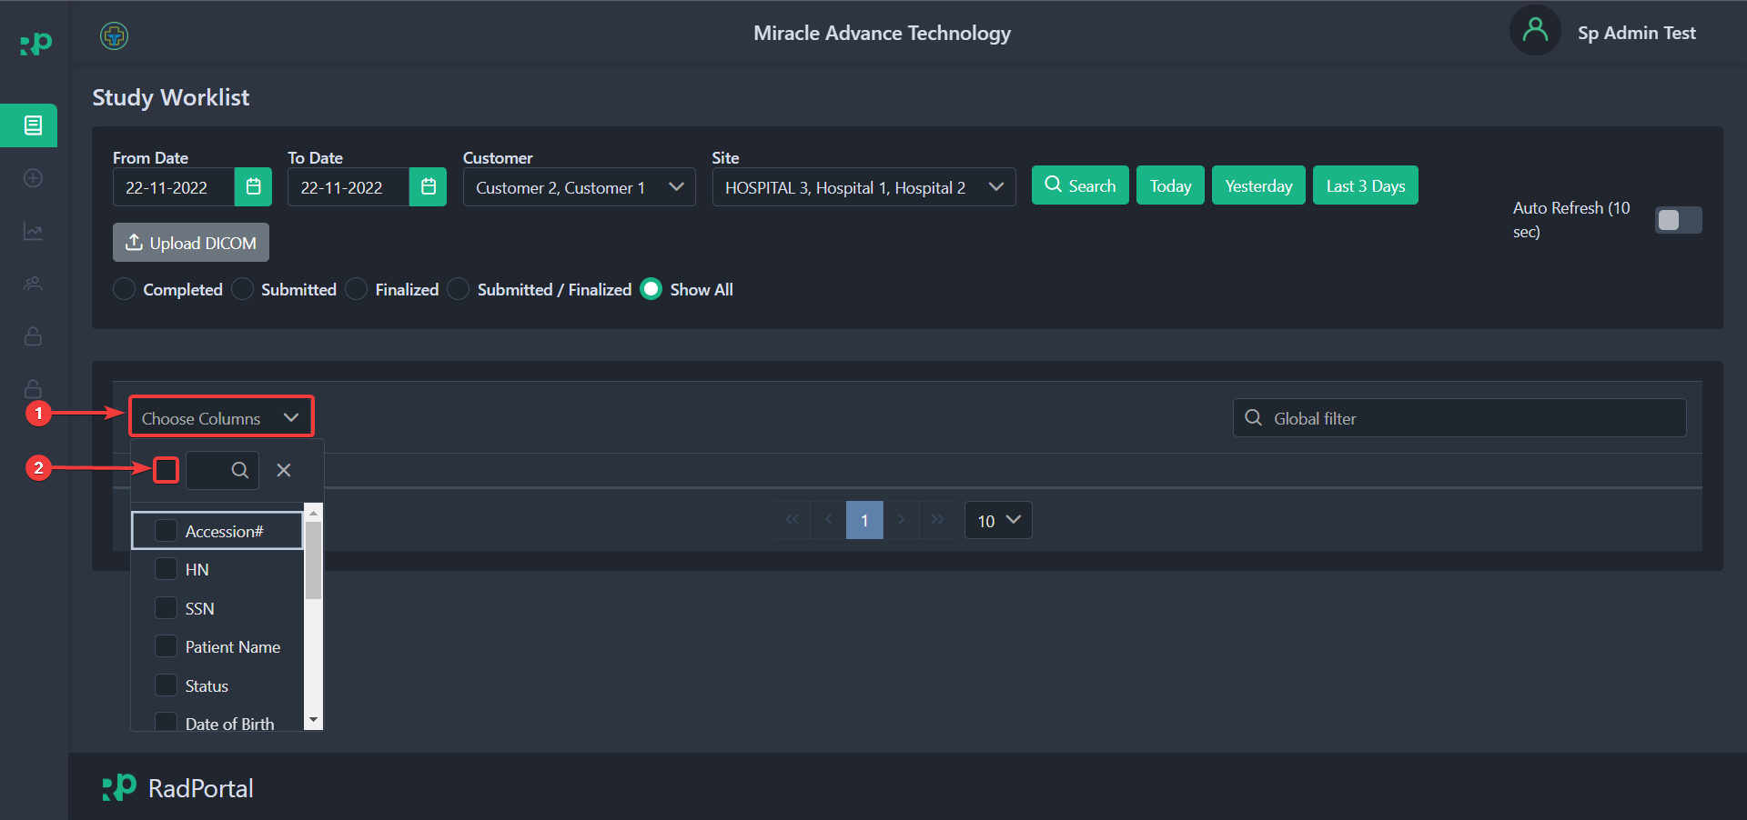

After clicking on the Checkbox, you should see that all information types are now activated.
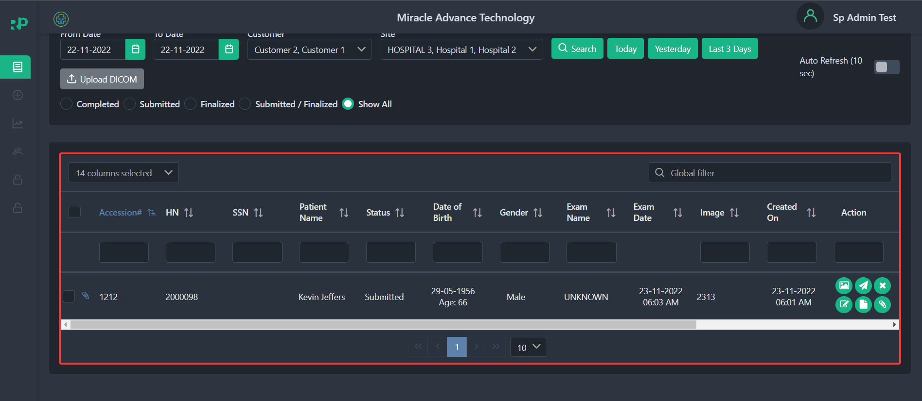

4.4 How to Review Images, Resend To PACS, Cancel, Edit, View Report and Attach Additional Documents to Studies

On the Study Worklist page, you can review Images of a Specific Study, resend them to PACS (Picture archiving and communication system), add, reconcile or delete studies, and attach necessary documents to existing studies. You can also assign radiologists to a specific study.

4.4.1 Review Images of a Specific Study
You can easily access all images of a specific study by clicking on the Image Icon in the screenshot below.
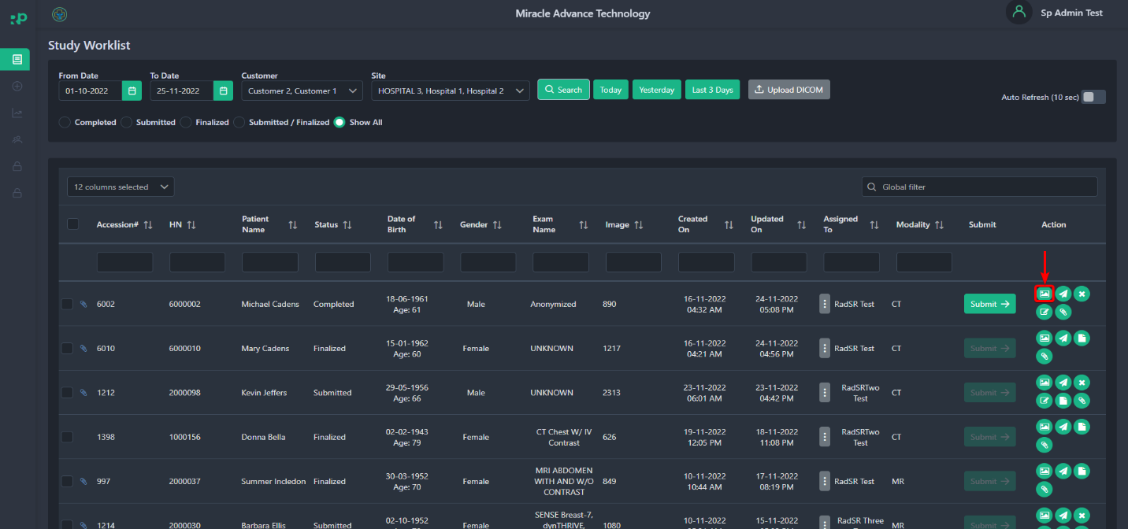

After clicking, you should see a popup window where you must sign in with a specific Username [1] and Password [2]. This step ensures that only authorized personnel can view the medical test images. Finally, click on the Sign In[3] button to sign in.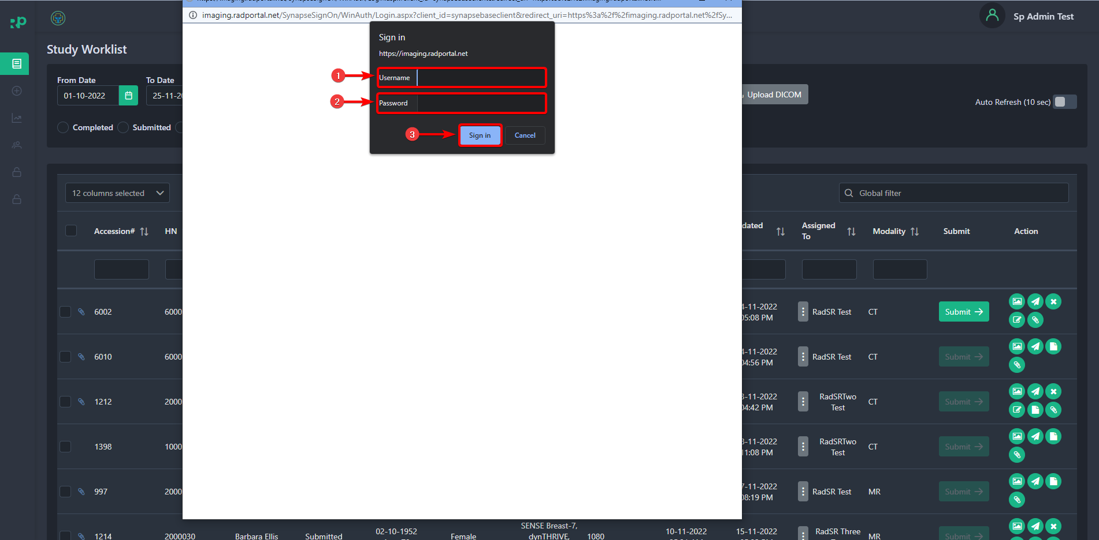

After successfully logging in to the system, you should be able to see all the test images of that specific Patient's medical test.
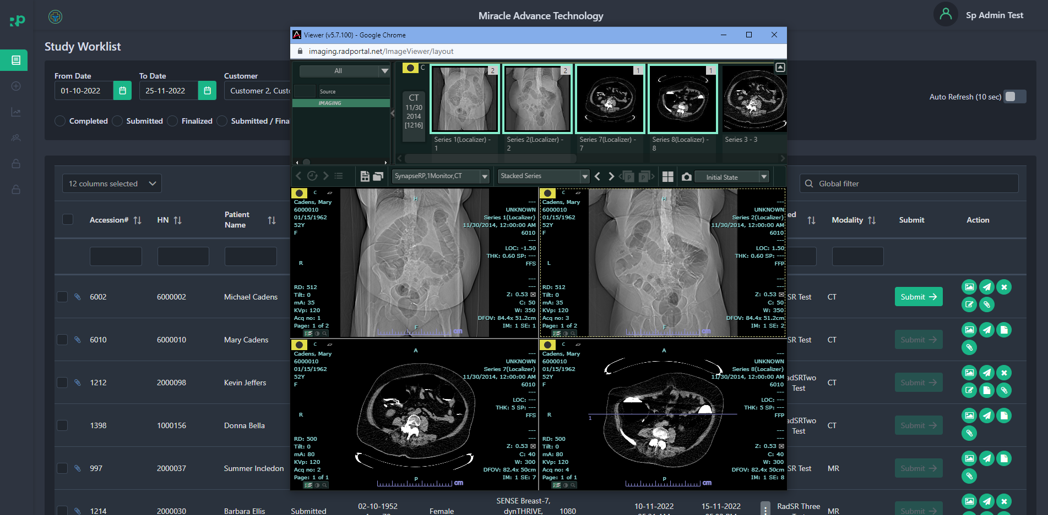

4.4.2 Resend to PACS (Picture archiving and communication system)
It's possible to resend studies from the local archive to the PACS if they were not correctly sent before.
To resend studies from the local archive to the destination PACS node, select the study (or multiple studies) and click on the Resend to PACS button.
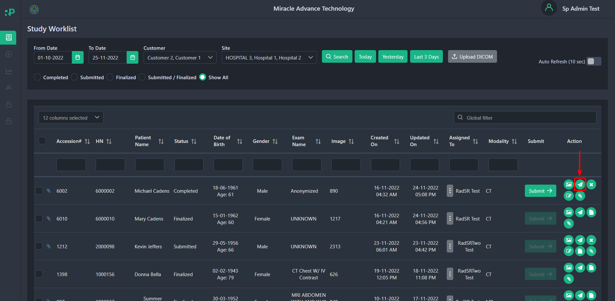

4.4.3 Cancel (Remove) Studies
Studies can be easily deleted from the RadPortal System. To remove studies, click on the Cancel button.
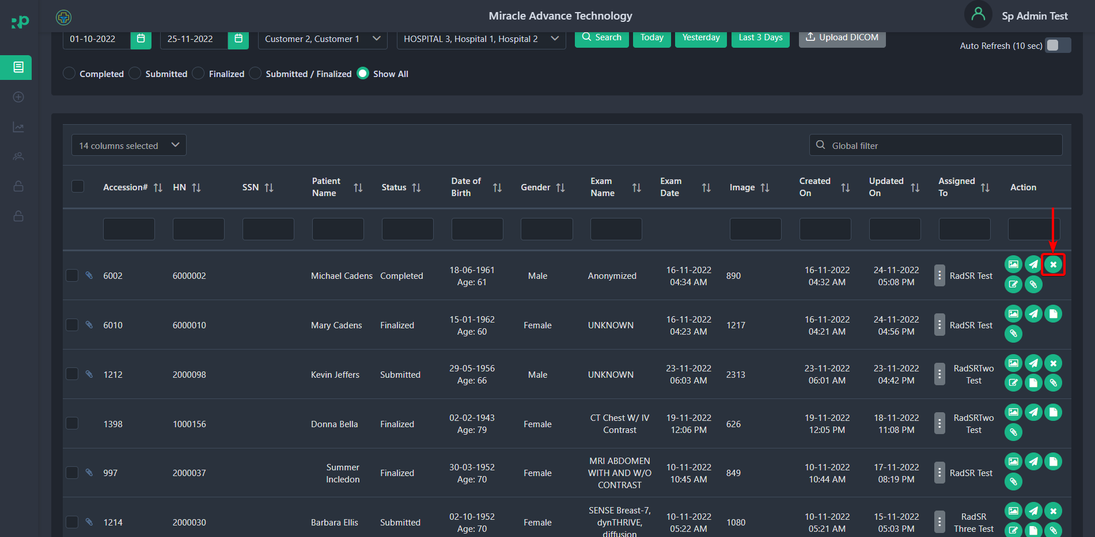

After clicking on the cancel button, you should see a popup window where you can specify the reason for deleting that particular study in the Reason [1] text field. To confirm the deletion of that study, click on the Yes [2] button, or if you do not want to delete the study, click on the No [3] button.
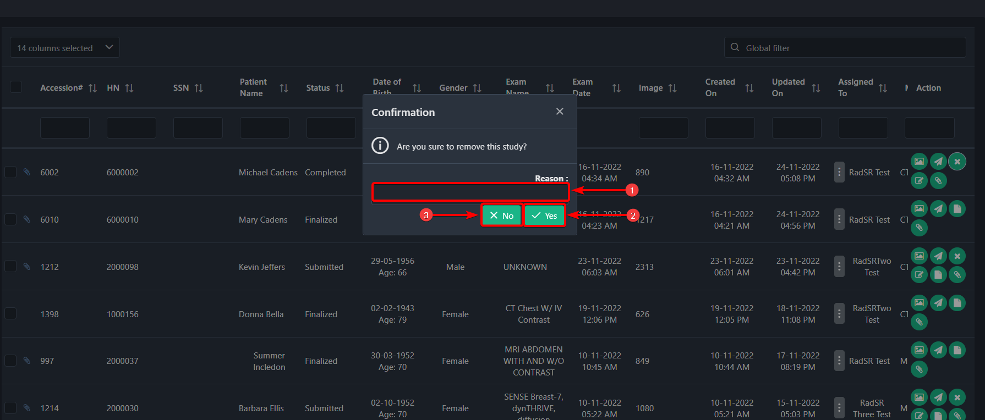

4.4.4 Reconcile Studies
You can easily reconcile studies in the RadPortal. By default, the RadPortal system collects information from the DICOM Files. So, you may need to reconcile/edit studies to attach additional information. You can edit/add information such as SSN, HN, First Name, Middle Name, Last Name, Gender, Age, DOB, Accession No, Study Date, and Study Govt Code.
To reconcile a particular study, click on the Reconcile button.
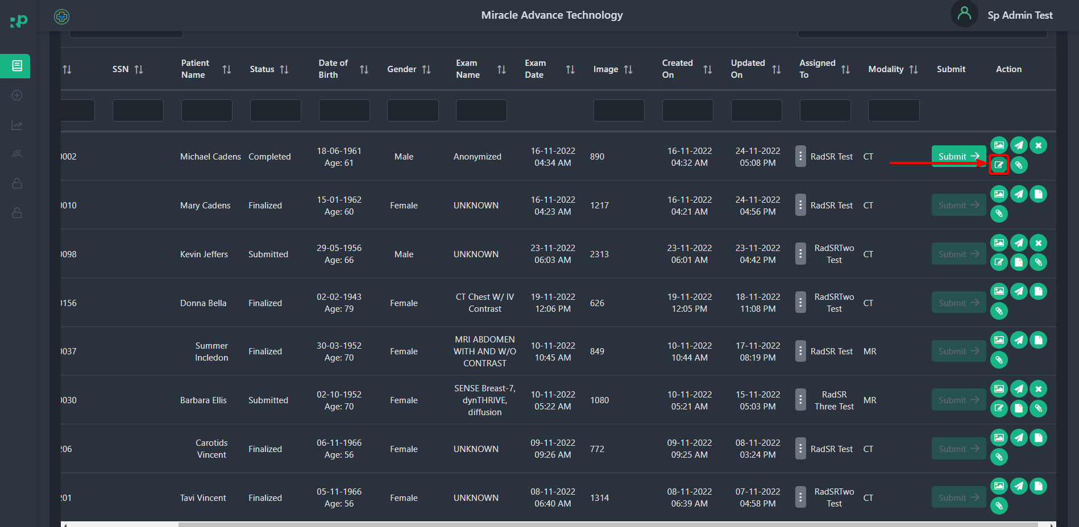

After clicking, you should see a popup where you can edit or update patient and study information.
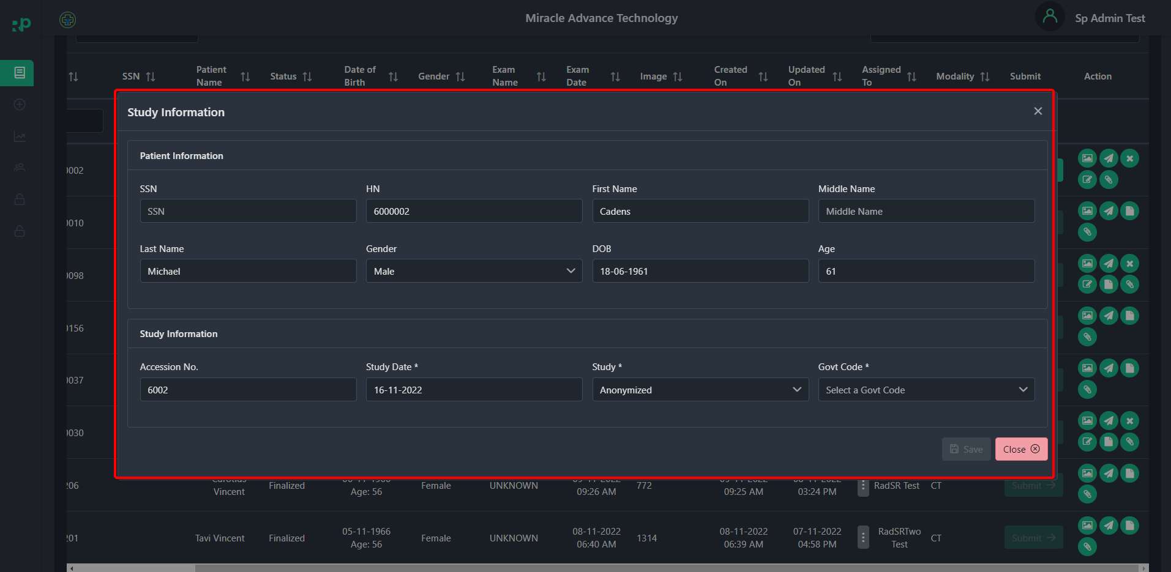

NOTE: When reconciling the study, you must fill in the Study Date, Study, and Govt Code

When you are done, click the Save button to save the updated information.
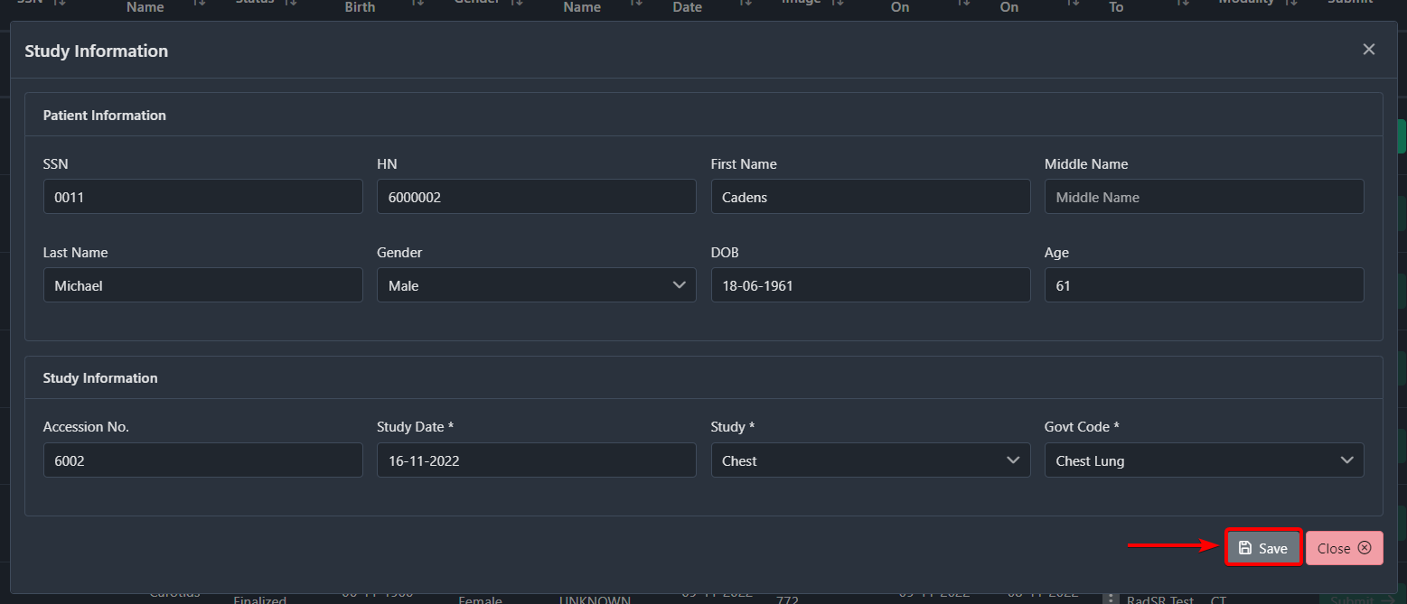

4.4.5 How to Submit Study/Case
You have to submit the Study/Case before you assign a radiologist. After you submit a study, it will automatically be sent to the PACS (Picture Archiving and Communication System). When a case has the Completed status, you should see the Submit Button Activated under the Submit field.

Now to submit the study, click on the Submit button.
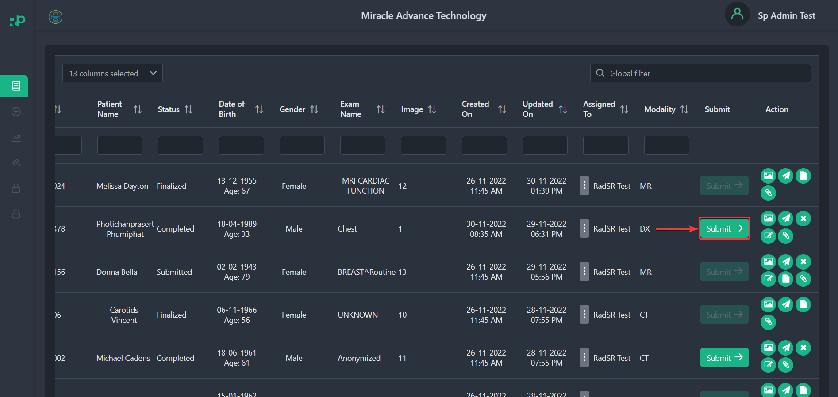

NOTE: After the hospital submits a study, the hospital will not be able to cancel the study.

4.4.6 View Study Reports
When a radiologist submits a report for a specific case/study, you can view the report by clicking on the View Report button.
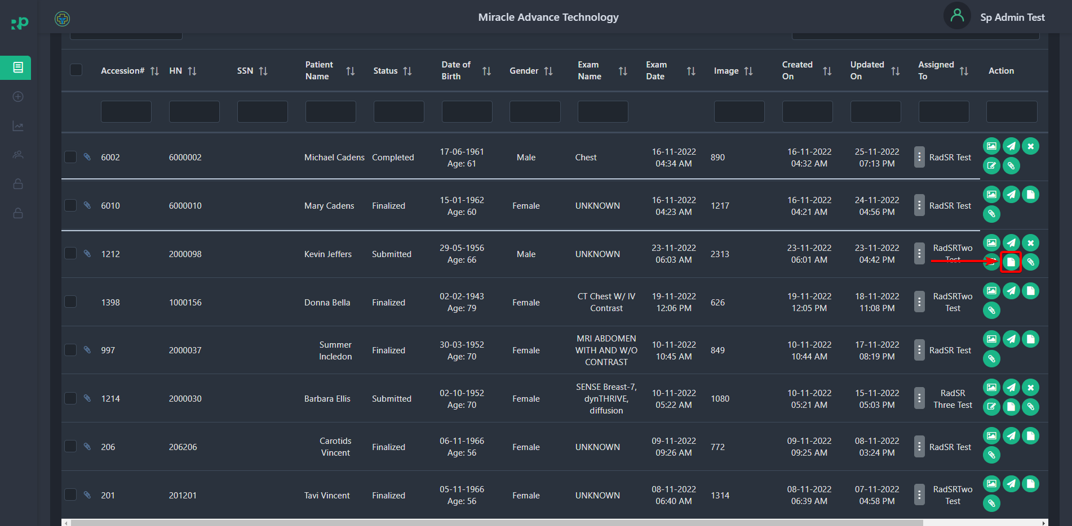

After clicking, you can see the Finalized report.
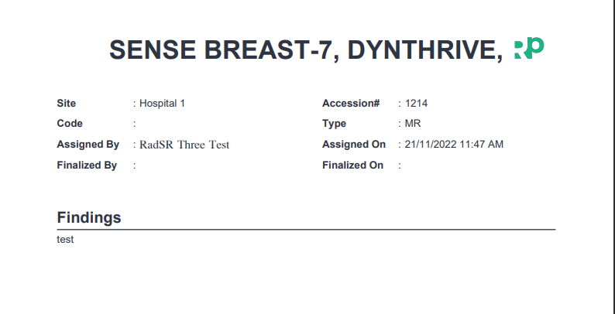

NOTE: You will only see the View Report button once the Radiologist has finalized the report from their end.

4.4.7 Attach Additional Files To A Study
You can attach additional files to a study by clicking on the Document Upload button.
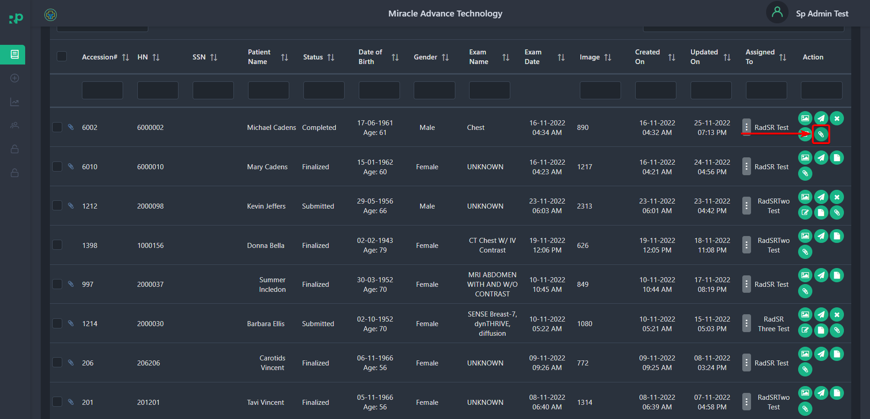

After clicking, you should see a popup window where you can define document Types [1] such as Report, Lab data, or Clinical diagnosis. Select the document from the local storage by clicking the Choose Files [2] button. Add the Name of the document you just uploaded in the Title Field [3], and finally, click on the Upload button [4].
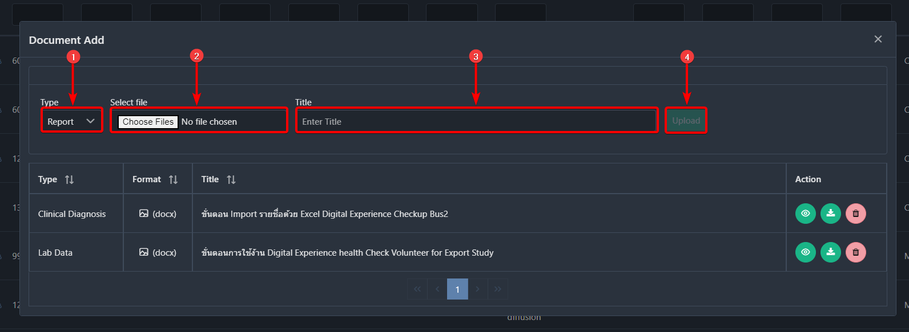

After completing the upload process, you should see the document in this list.
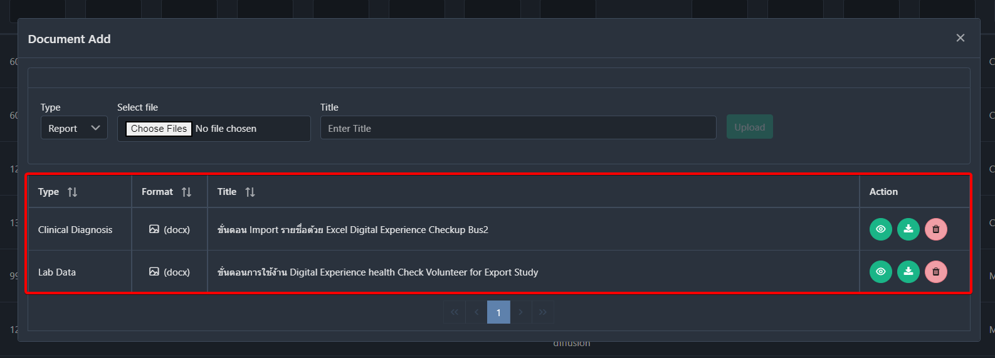

You can view, download or delete the document by clicking on the View [1], Download [2], and Delete [3] buttons.
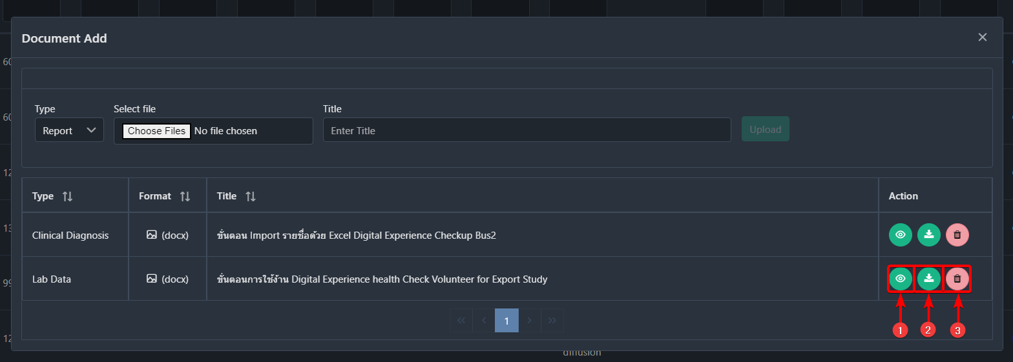

4.6 How to Submit Studies
When a Healthcare Service Provider uploads studies, you can see them in the worklist with the status of Completed.
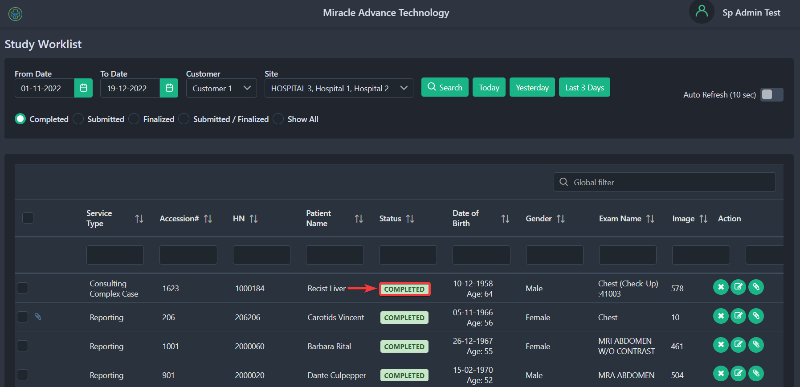

Now, you have to reconcile study data before you submit the study. To reconcile, click on the Reconcile button.
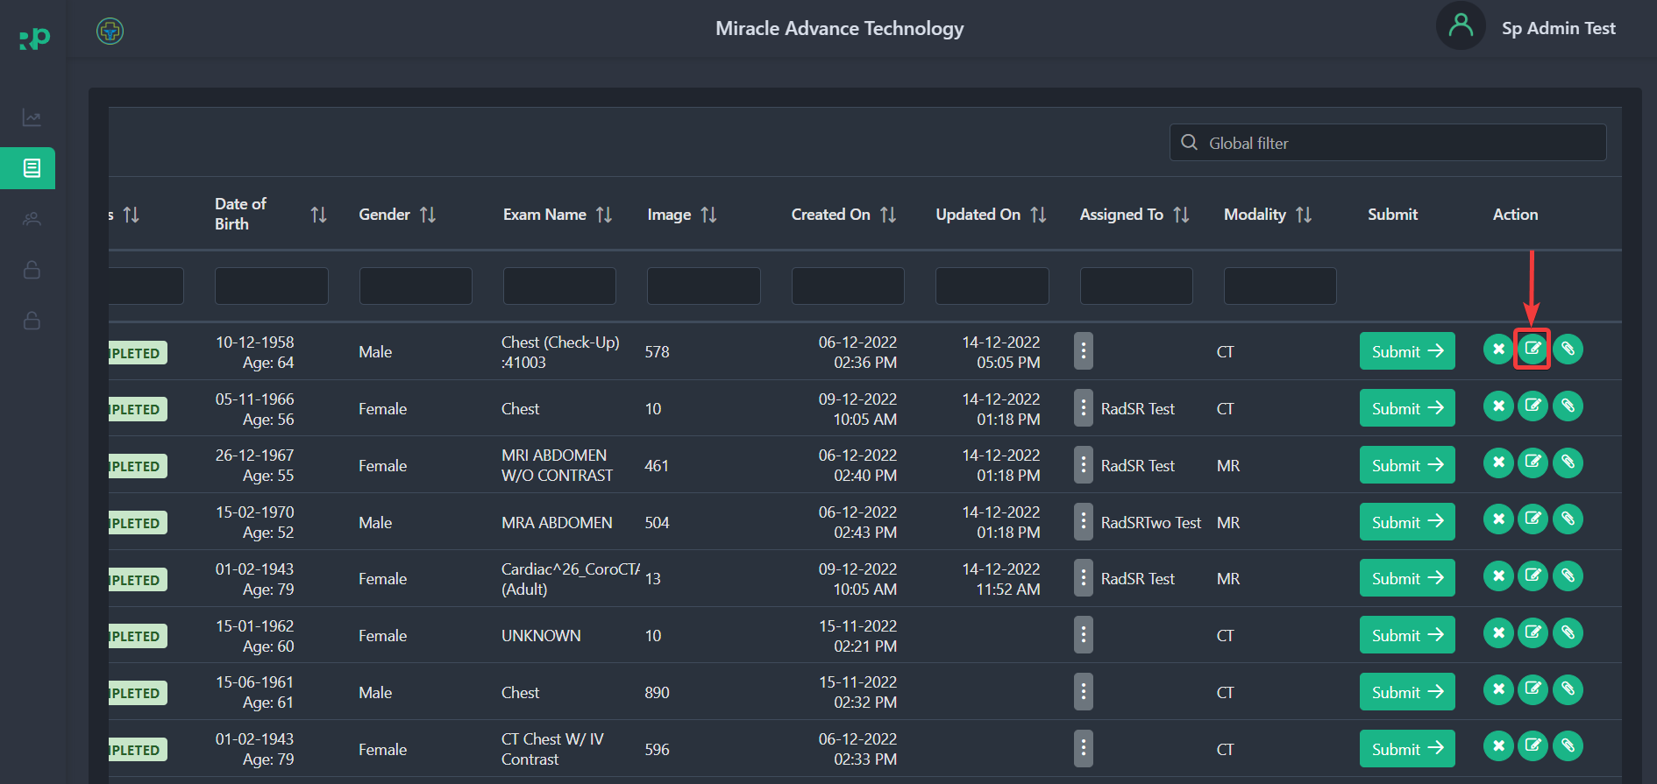

After clicking, you will see a popup window where you can update all patient information. 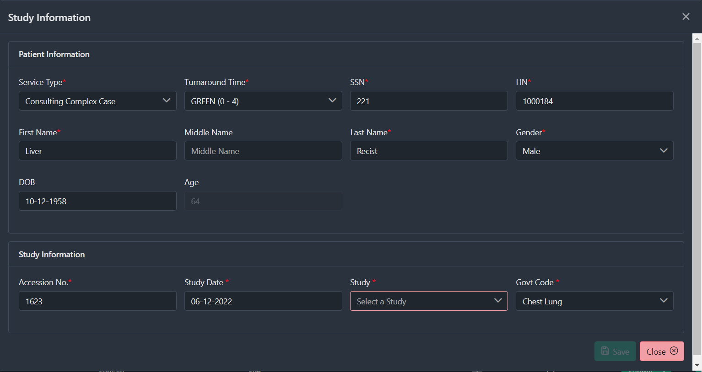

To complete the reconciling process, you must assign Study Code[1] and Govt Code[2].
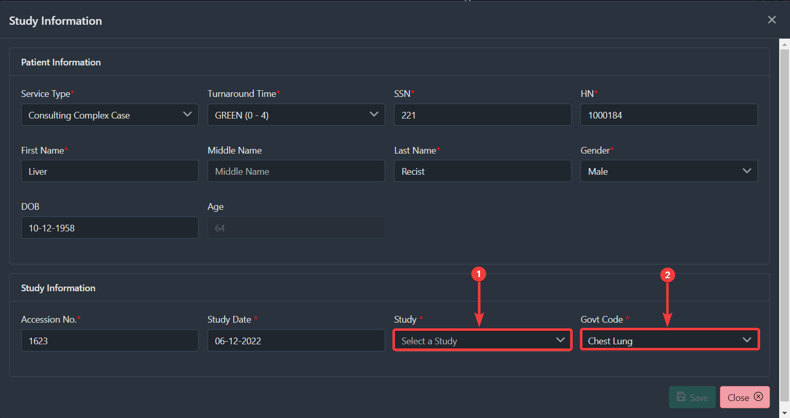

After assigning study and govt codes, click on the Save button.
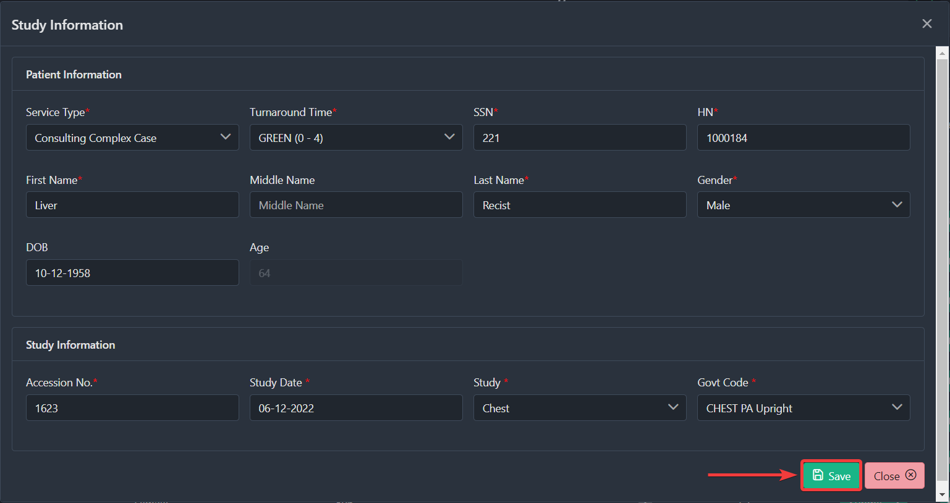

After you complete the reconciliation process, you will be able to submit the studies. Only the Service Provider(admin) and the Customer are allowed to submit studies.
To submit the study, click on the Submit button. 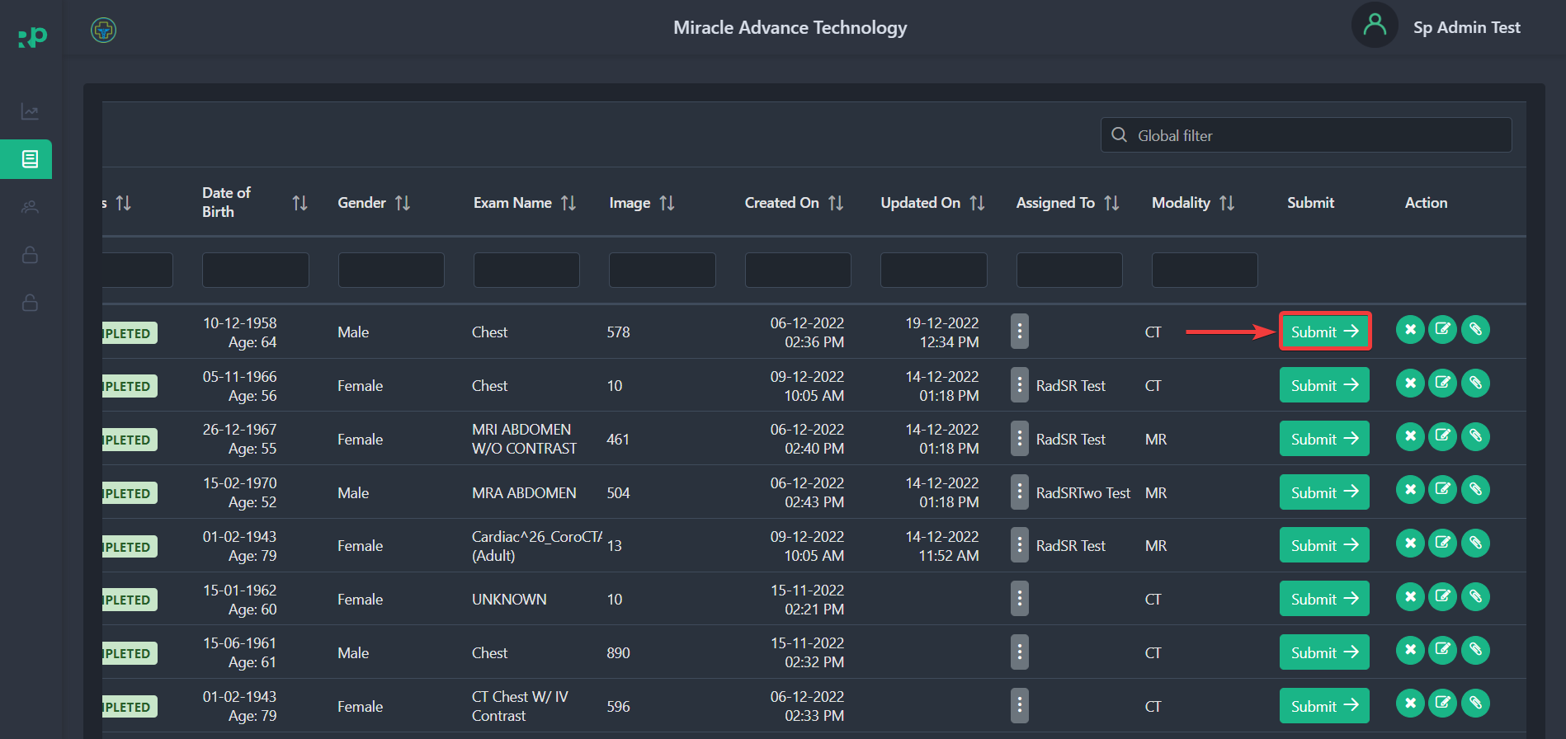

After clicking on Submit button, you should see the same popup window where now you should see the Save & Submit button. To submit, click on it.
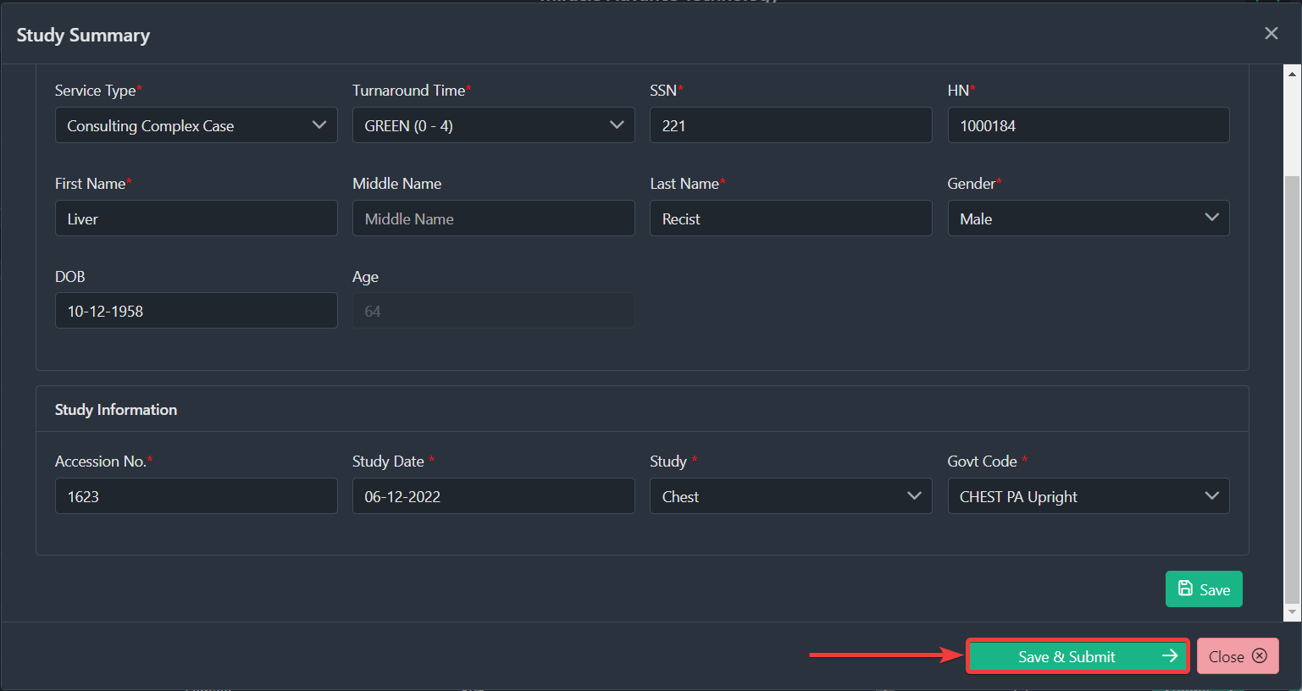

4.7 How to Assign a Radiologist to a Case/Study
Any Submitted studies can be assigned to a radiologist. You can easily assign available radiologists to a particular case/study. To assign a radiologist, you have to click on the Kebab Menu Icon under the Assign To section.
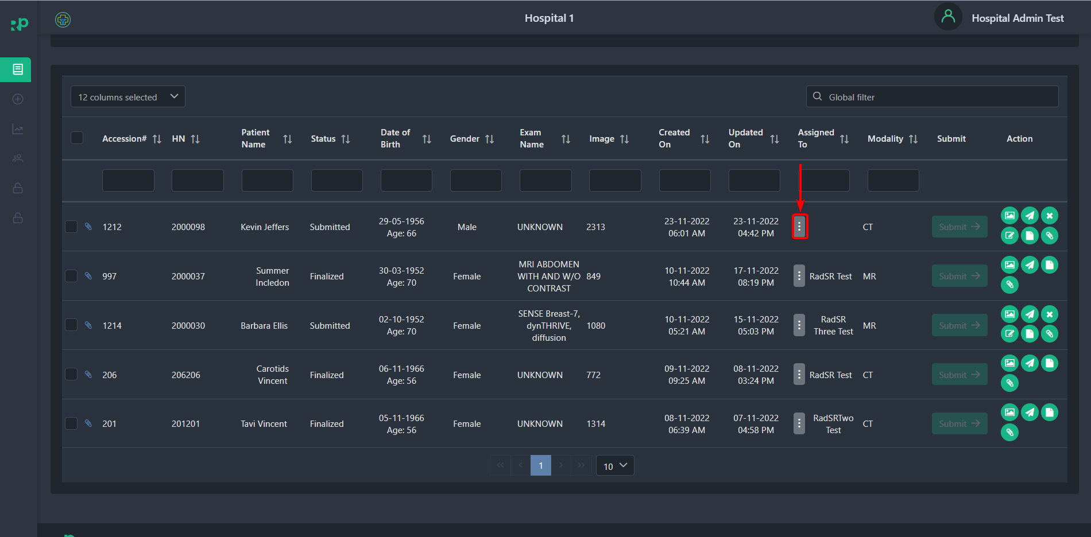

After clicking, you should see a popup window.
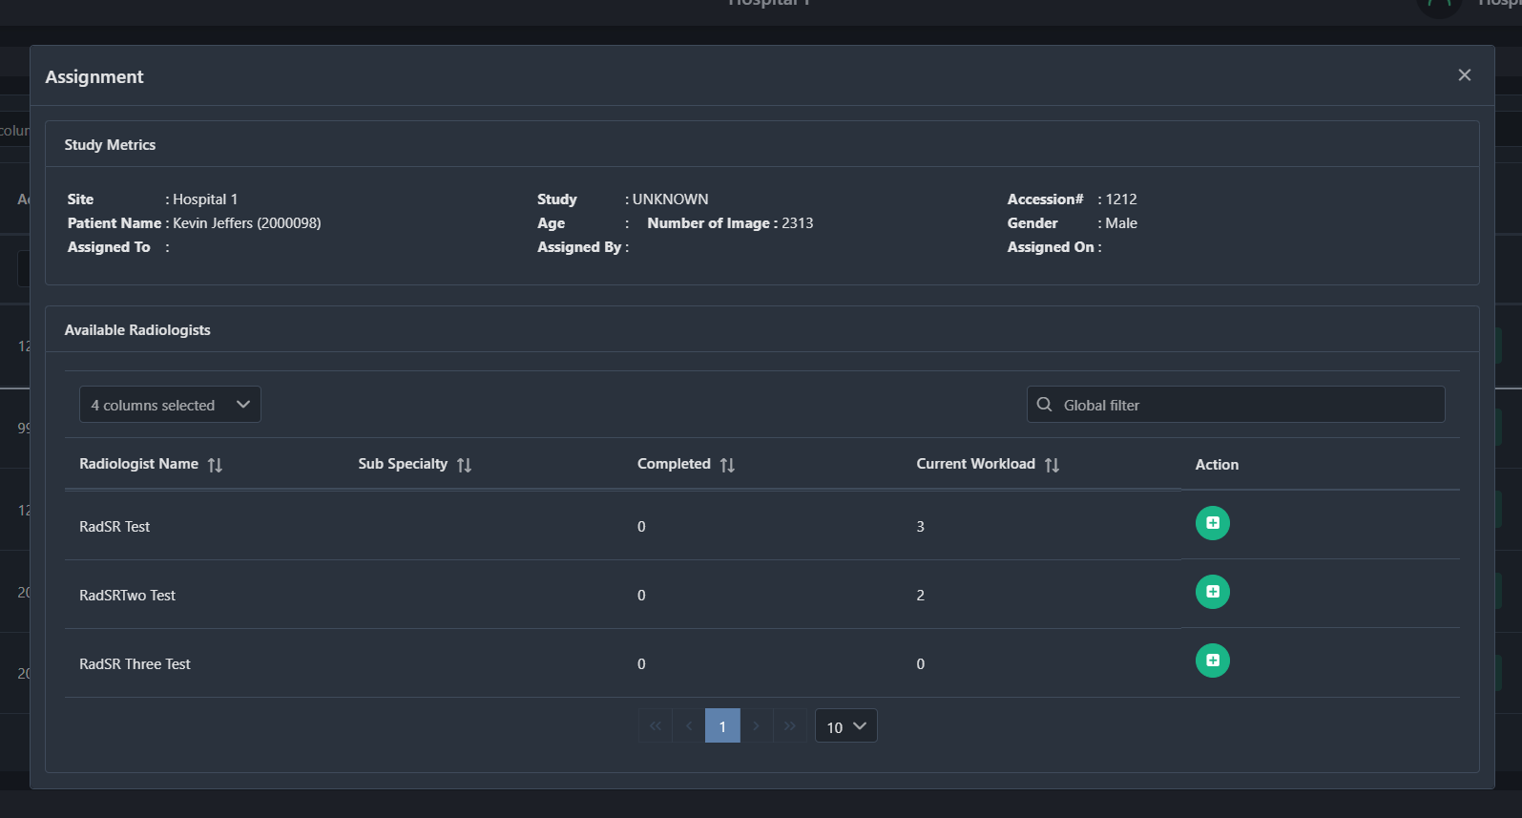

There you will see the list of available radiologists.
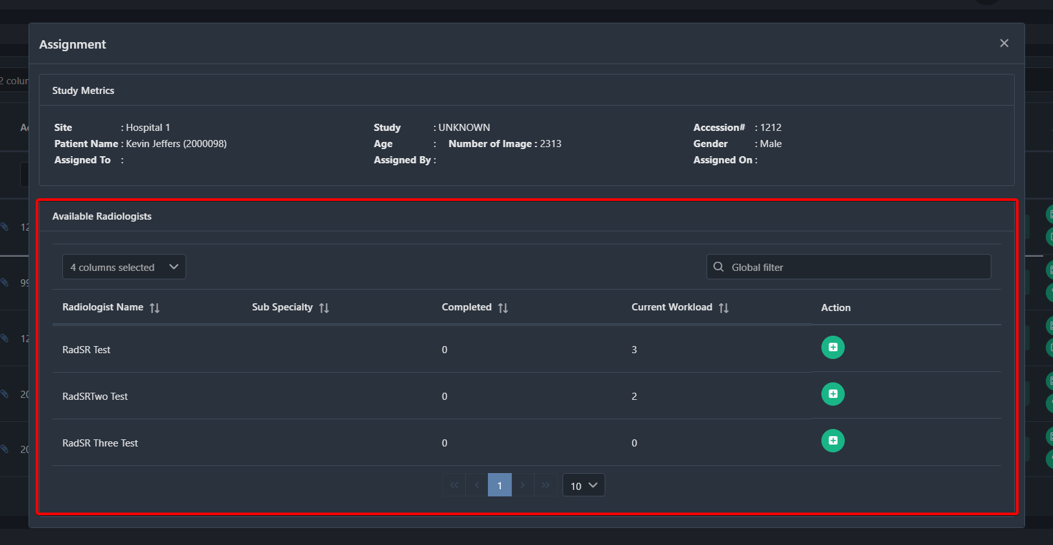

To assign a radiologist, click on the Plus Icon.
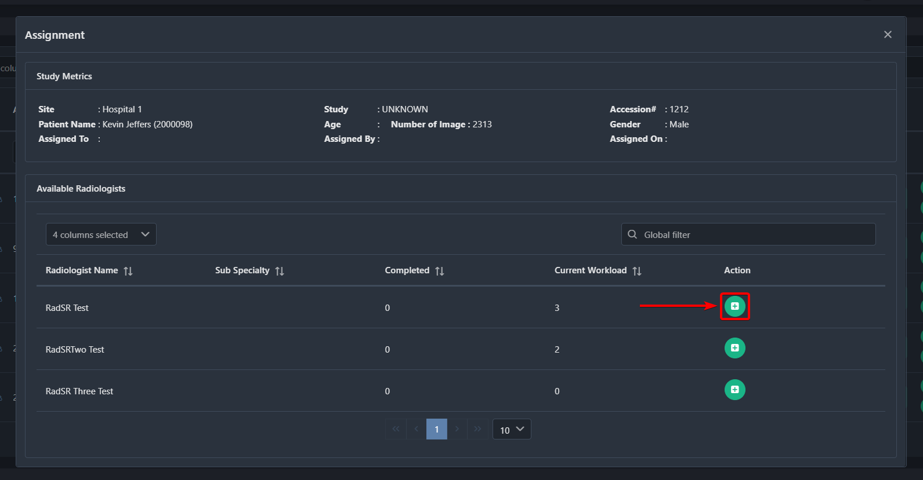

After clicking, you should see another popup window asking for your confirmation. Click on Yes to confirm or no to return to the Assignment page.
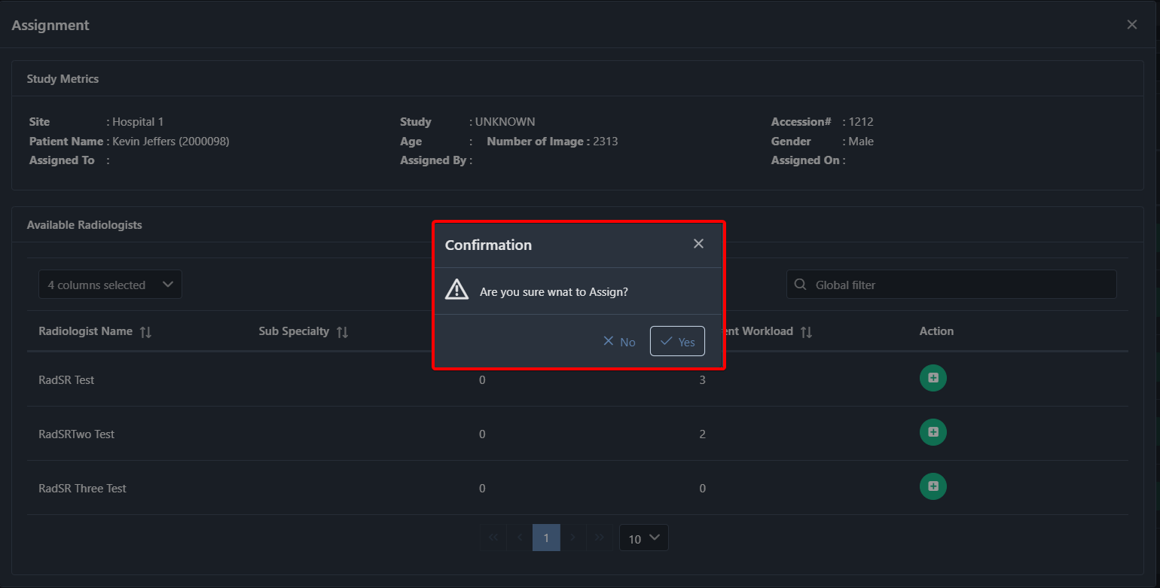

5. Registration Menu
This menu in the RadPortal system allows you to manually register new studies with patient information. There are 2 sections you have to fill in before you try to register a new patient.
You have to fill in
- Patient Information
- Study Information
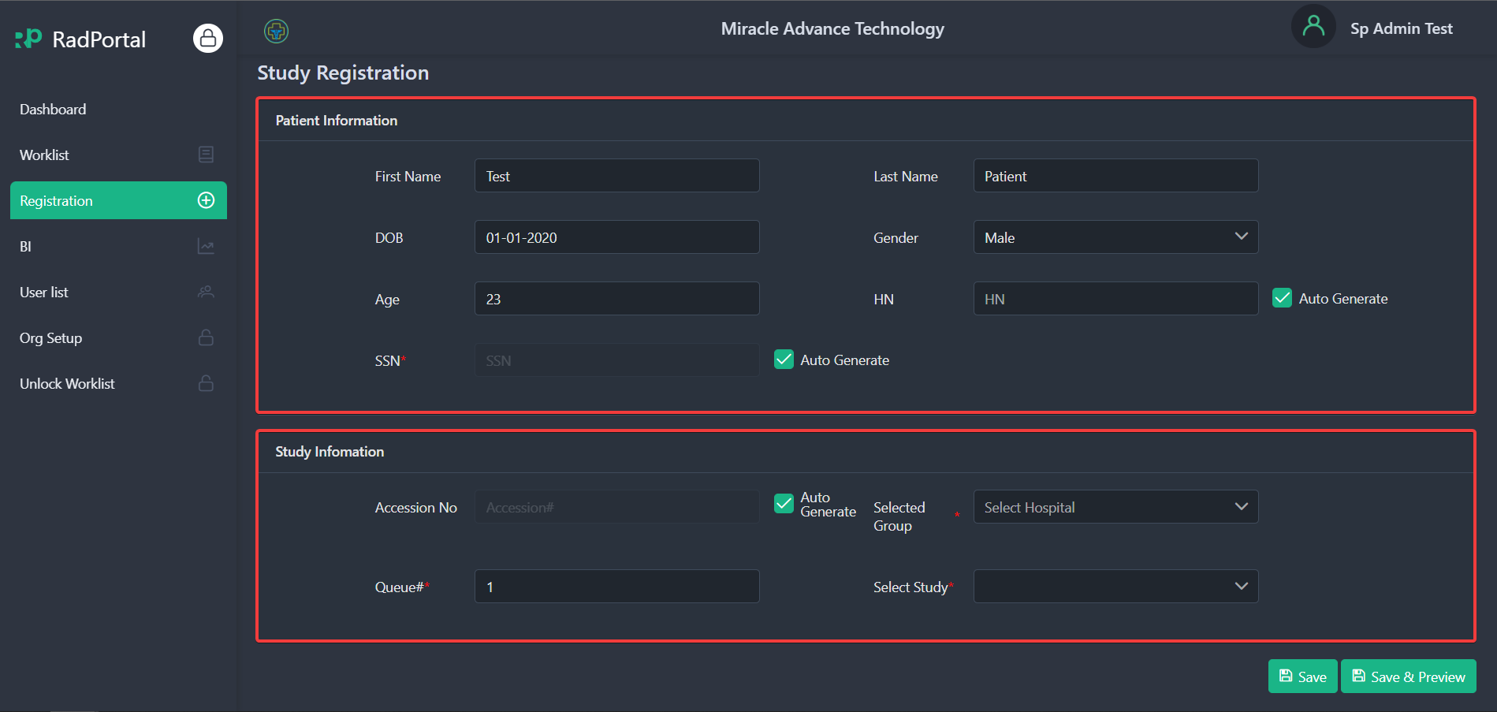

Patient Information:
To register a new Case/Study, you have to submit information such as the Patient's First Name [1], last Name [2], DOB (Date of Birth) [3], Gender [4], Age [5], HN (Hospital Number) [6], and SSN (Social Security Number) [7]. 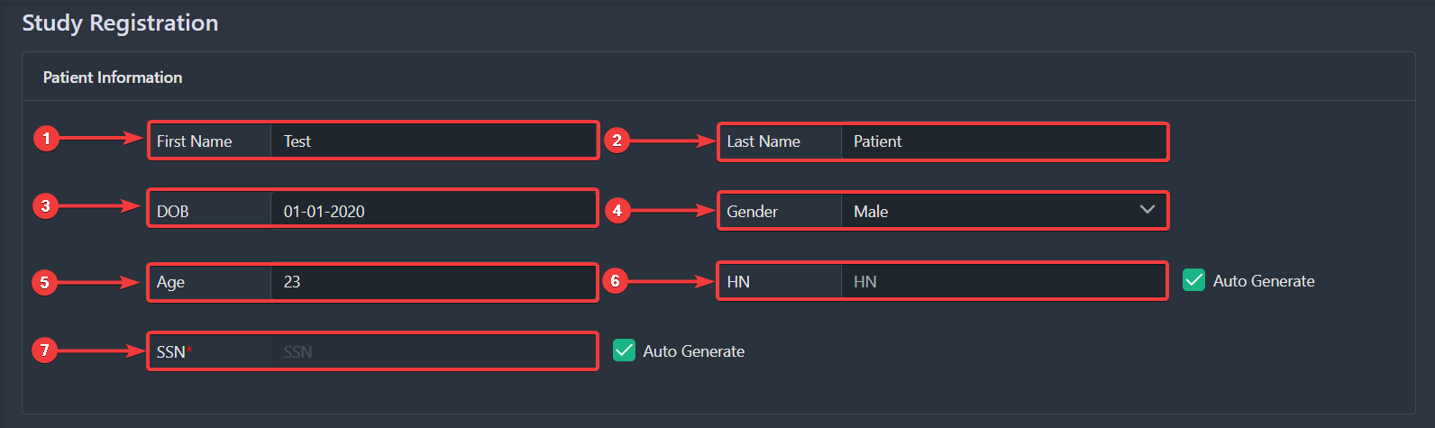

Study Information
In the next Field, you have to fill in study information such as Accession No. [1], Select Groups [2], Queue Number [3], and Select Studies [4].
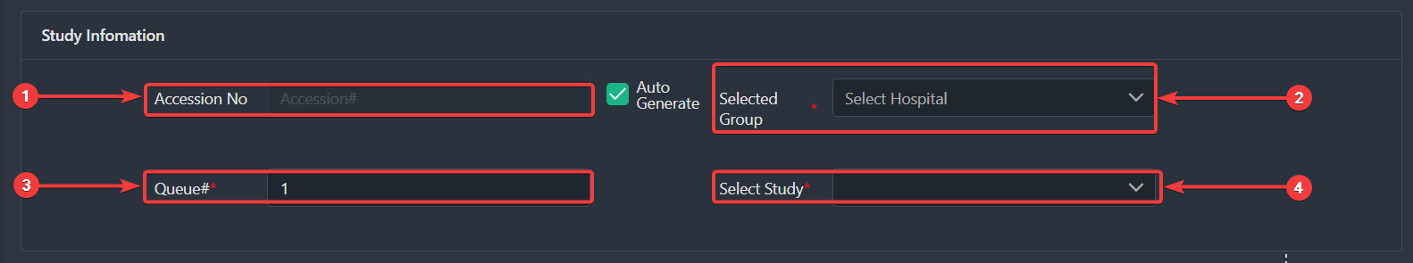

Finally, click on the Save [1] button to save or click on the Save & Preview [2] to see a preview after saving.
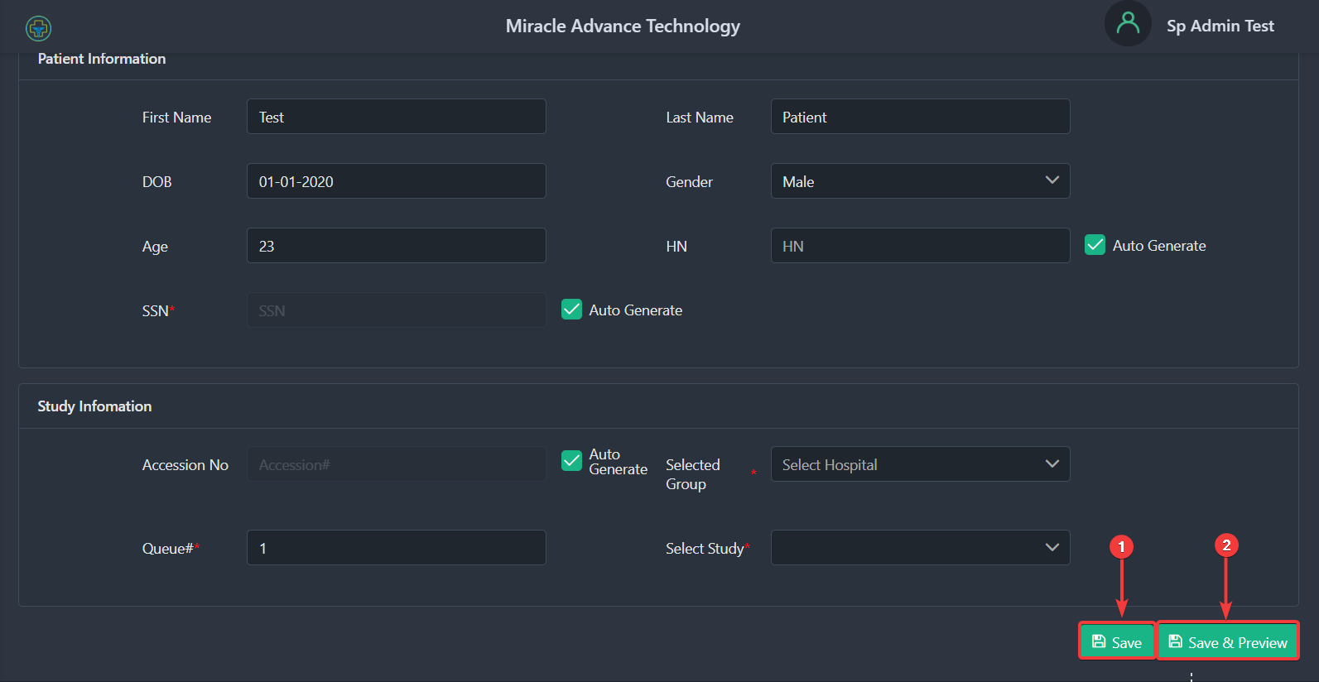

6. User list
This menu in the RadPortal system allows you to review all users in the RadPortal system. You also can Add, Modify or Remove users. The user list menu page should look like the screenshot below.
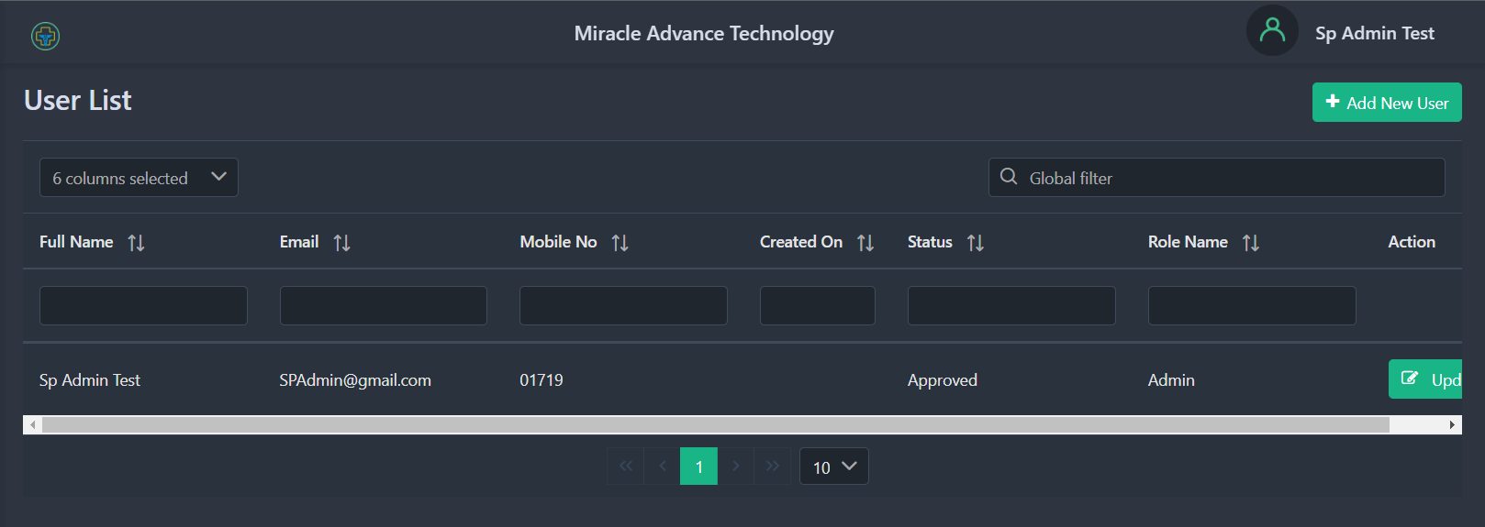

6.1 How to Add New Users
You can easily add users to the RadPortal system. To add a new user, click the Add New User button on the top right side of the page.
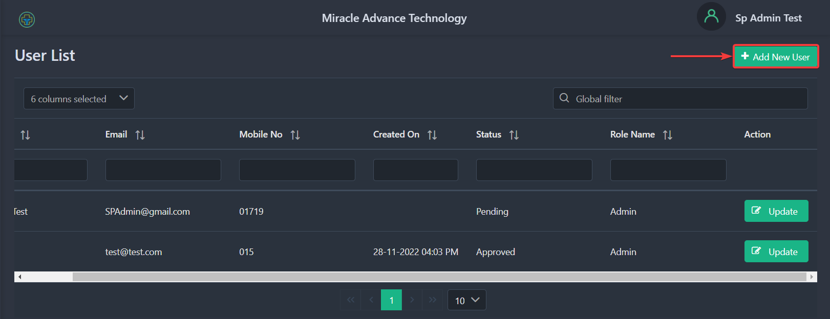

After clicking, you should see a new popup page where you can add information about the new user. You can add information such as First Name [1], Last Name [2], Phone No [3], Email [4], Password [5], Confirm Password [6], and User Role [7].
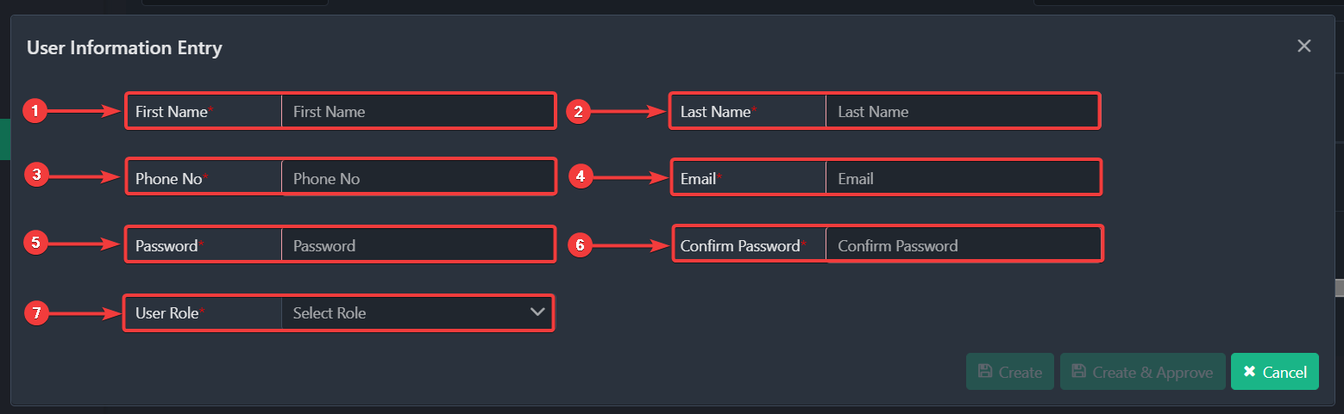

In the user role drop-down, you can choose user roles such as Admin[I], Radiologist [II], Clinician [III], and Help Desk [IV].
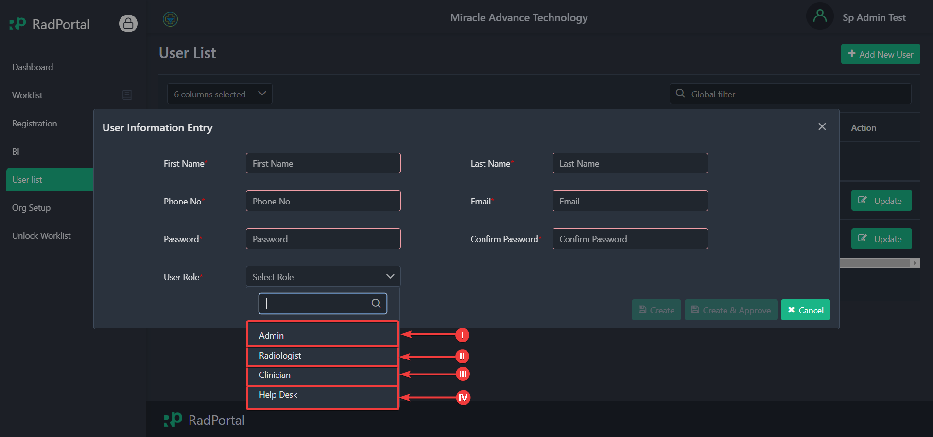

After you fill in all the information, you can click on the Create button to create the new user, and you can click on Save & Approve to create and approve the new user and click on Cancel to go back to the User list page.
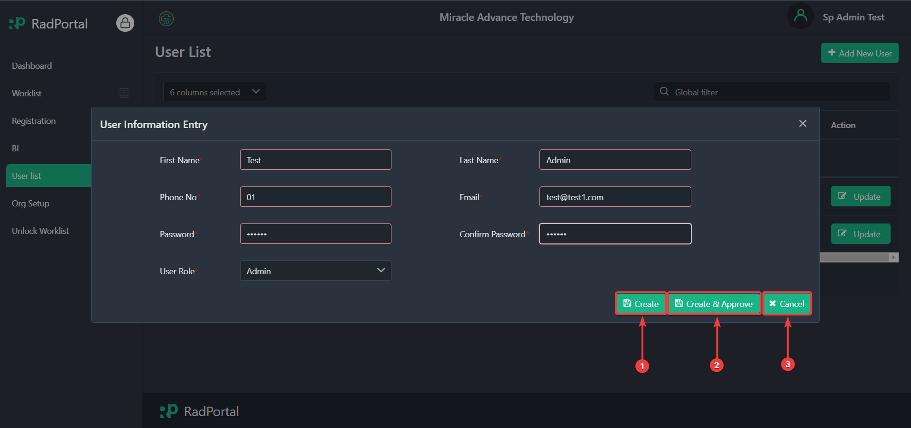

If you have clicked on the create button, you have to approve the new user before they try to log in to the RadPortal system. The new user will not be able to log in if their account is not approved.

6.2 How to Approve and Update User Information
You can approve the users you just created. You can also edit or update your user's information by clicking on the Update button.
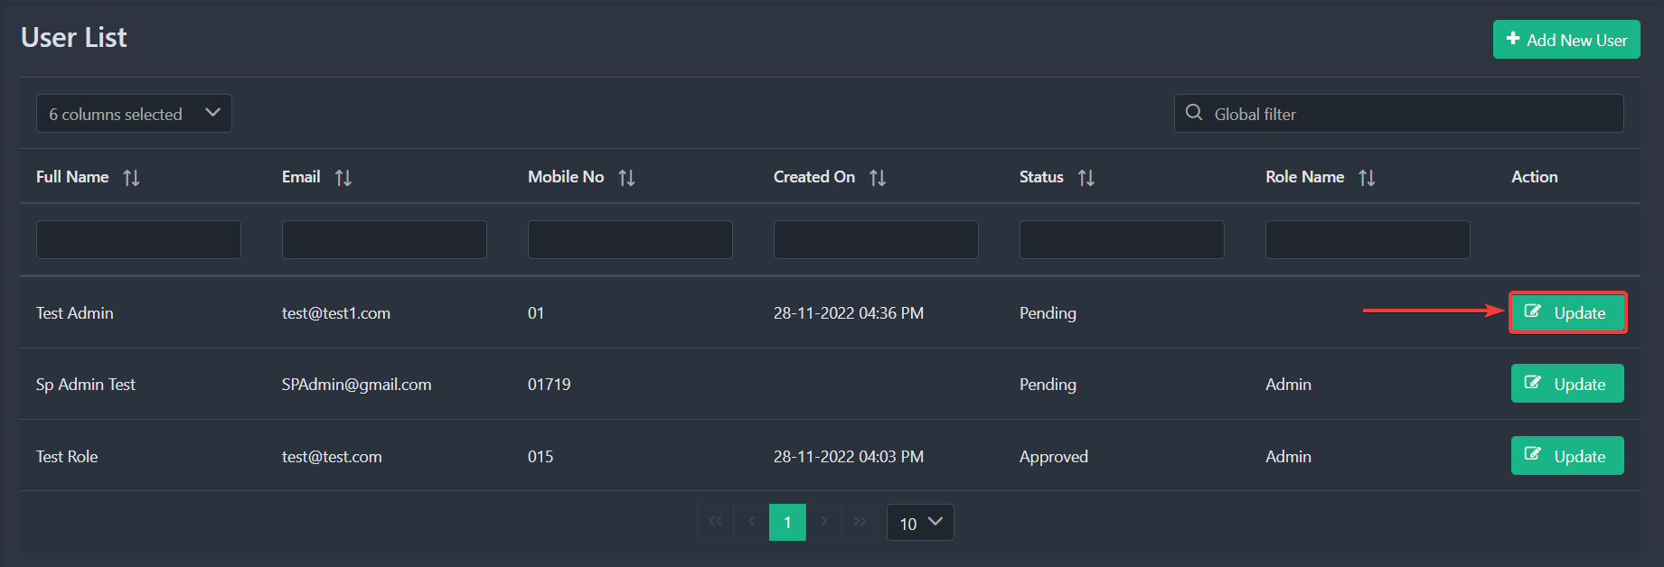

After clicking on the Update, you should see a new popup window to edit user information.
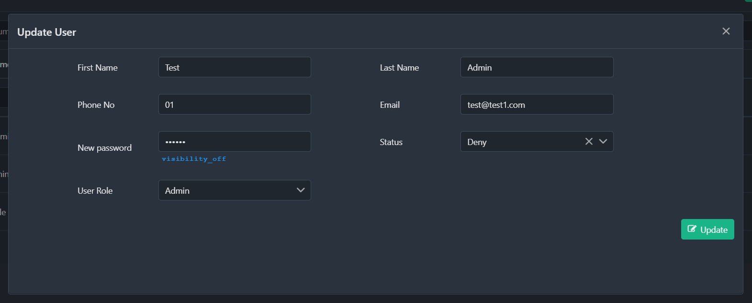

To approve a user, you have to click on the Status Dropdown [1] and select Approve [2] and click on Update [3].
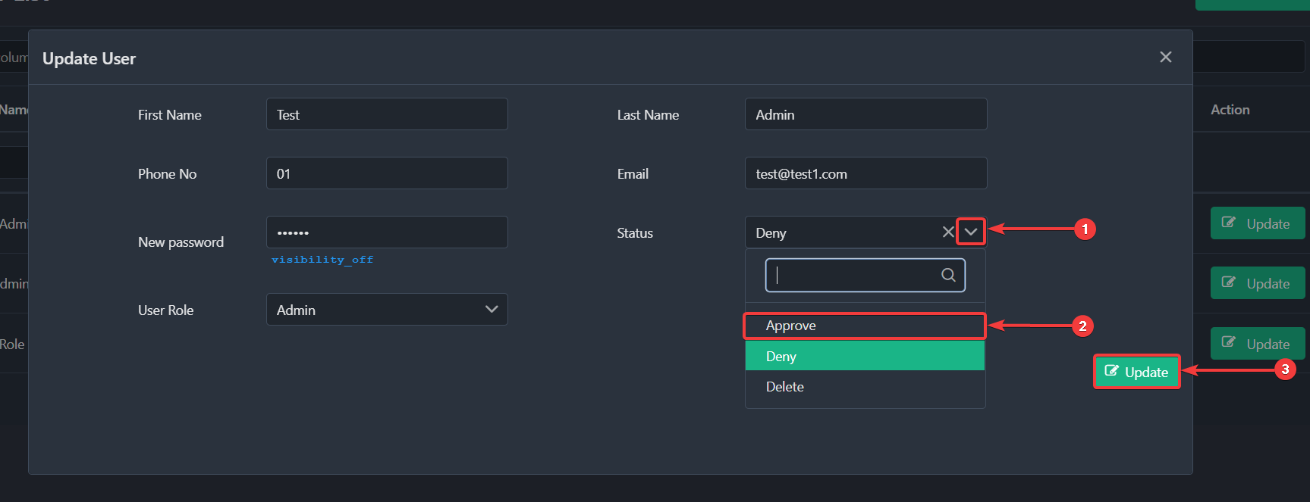

6.3 How to Organize Information of Users
Currently, you can view 8 types of information that you can show in the study worklist page, such as:
- Organization ID: Show's the Organization unique Identity number.
- Organization Type: Show the organization type.
- Full Name: Shows the user's full Name.
- Email: Shows the users login email address
- Mobile No: shows the user's mobile number
- Created On: Show the Date the user was created.
- Status: It shows the status of a particular user role.
- Role Name: Shows the user's role name.
To activate an information type, click on Choose Columns [1] and find the information type you want to activate. Click on the Checkbox [2] before the information type to activate.
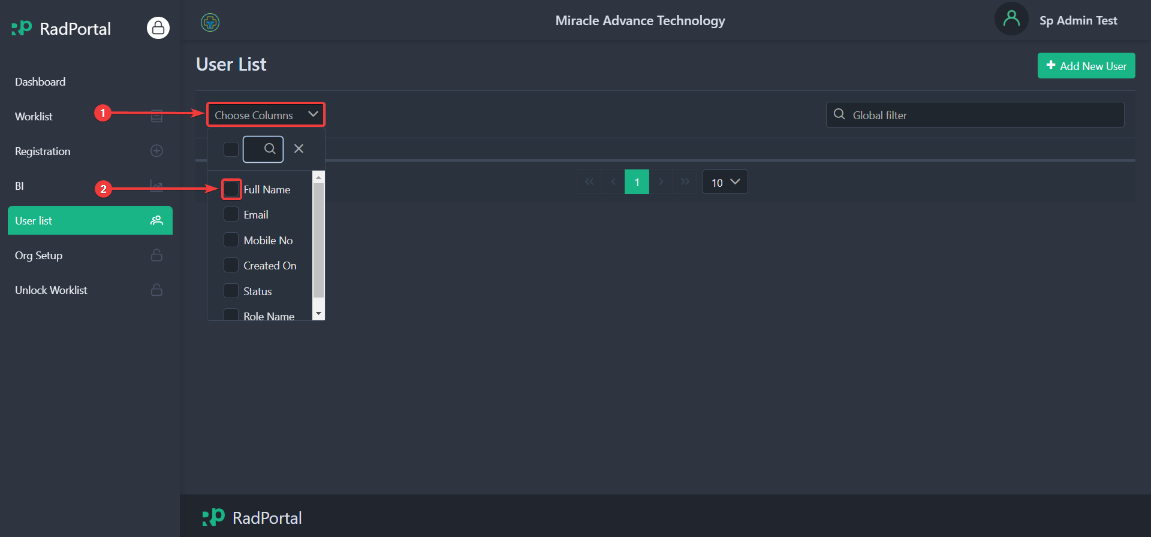

After selecting, you should see that the specific information type is activated.
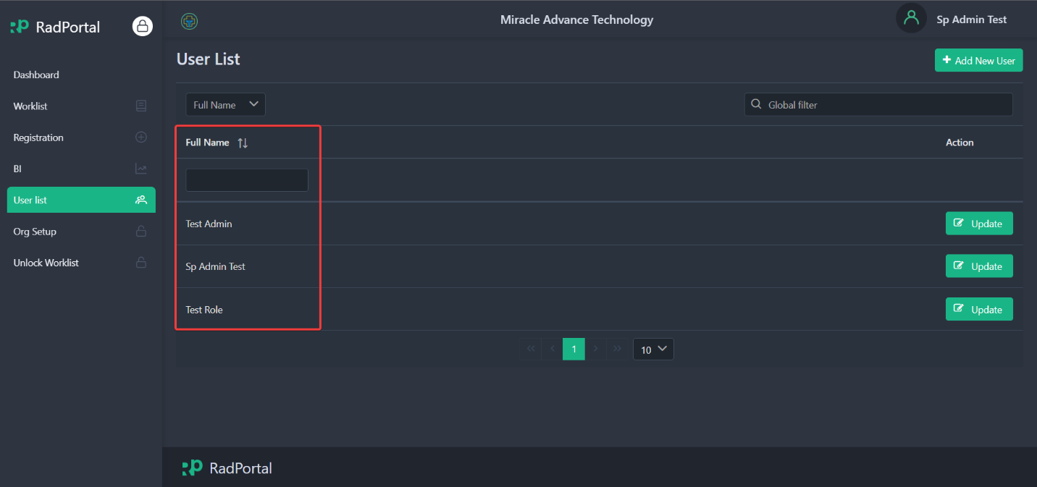

You can activate all information types by clicking on Choose Columns [1] and then clicking on Checkbox [2] at the top of the dropdown.
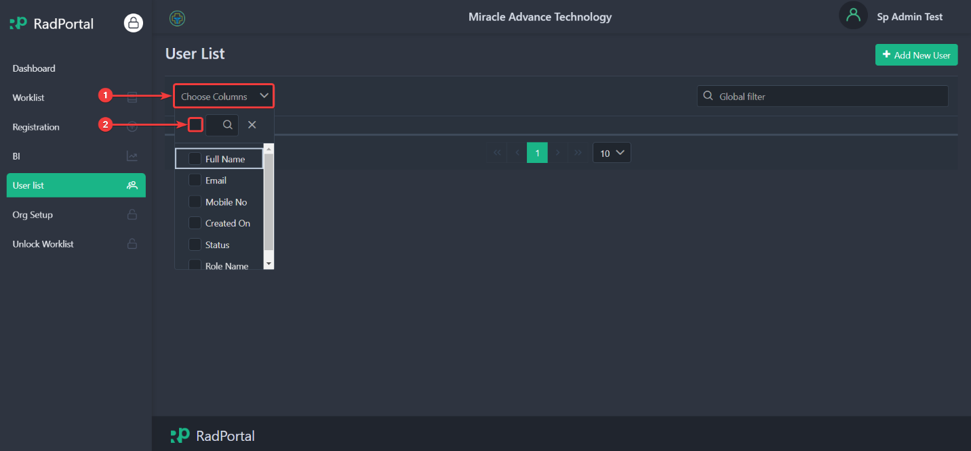

After clicking on the Checkbox, you should see that all information types are activated.
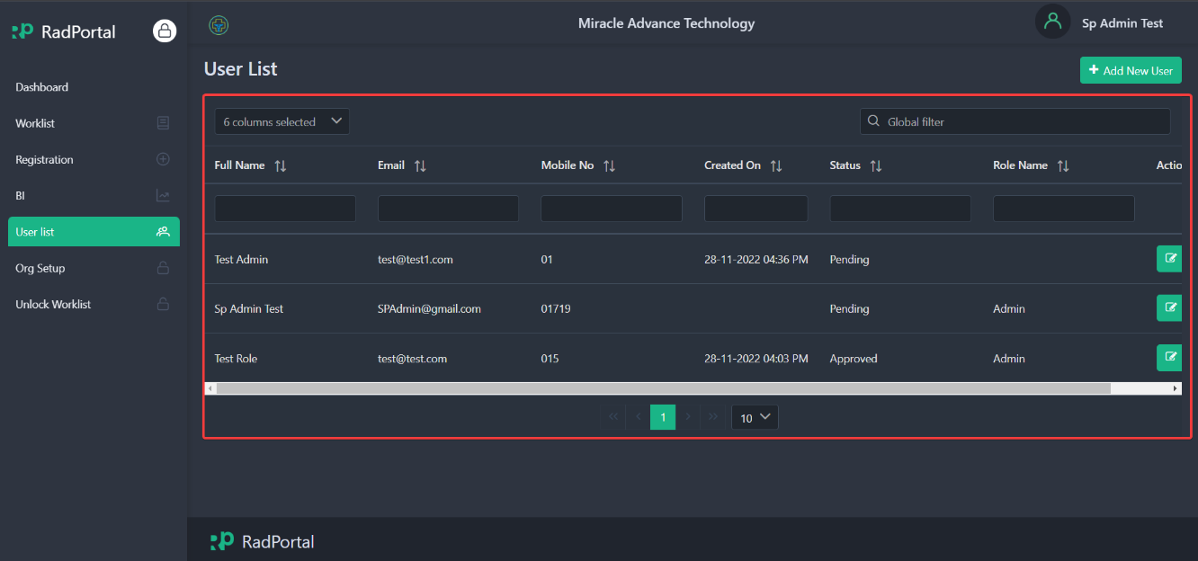

7. Organization Setup
This menu in the RadPortal system allows you to review all organizations configured in the RadPortal system. You also can Add, Modify or Remove organizations. The Organization Setup page should look like the screenshot below.
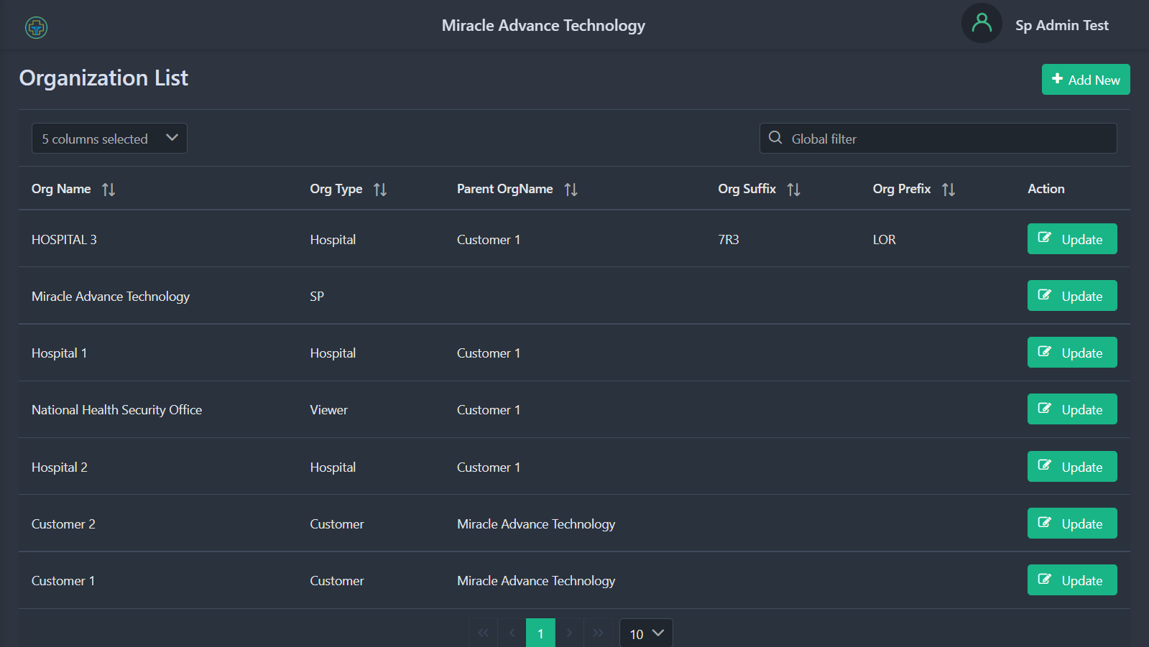

7.1 How to Add New Organization
You can easily add Organization to the RadPortal system. To add a new organization, click the Add New button on the top right side of the page.
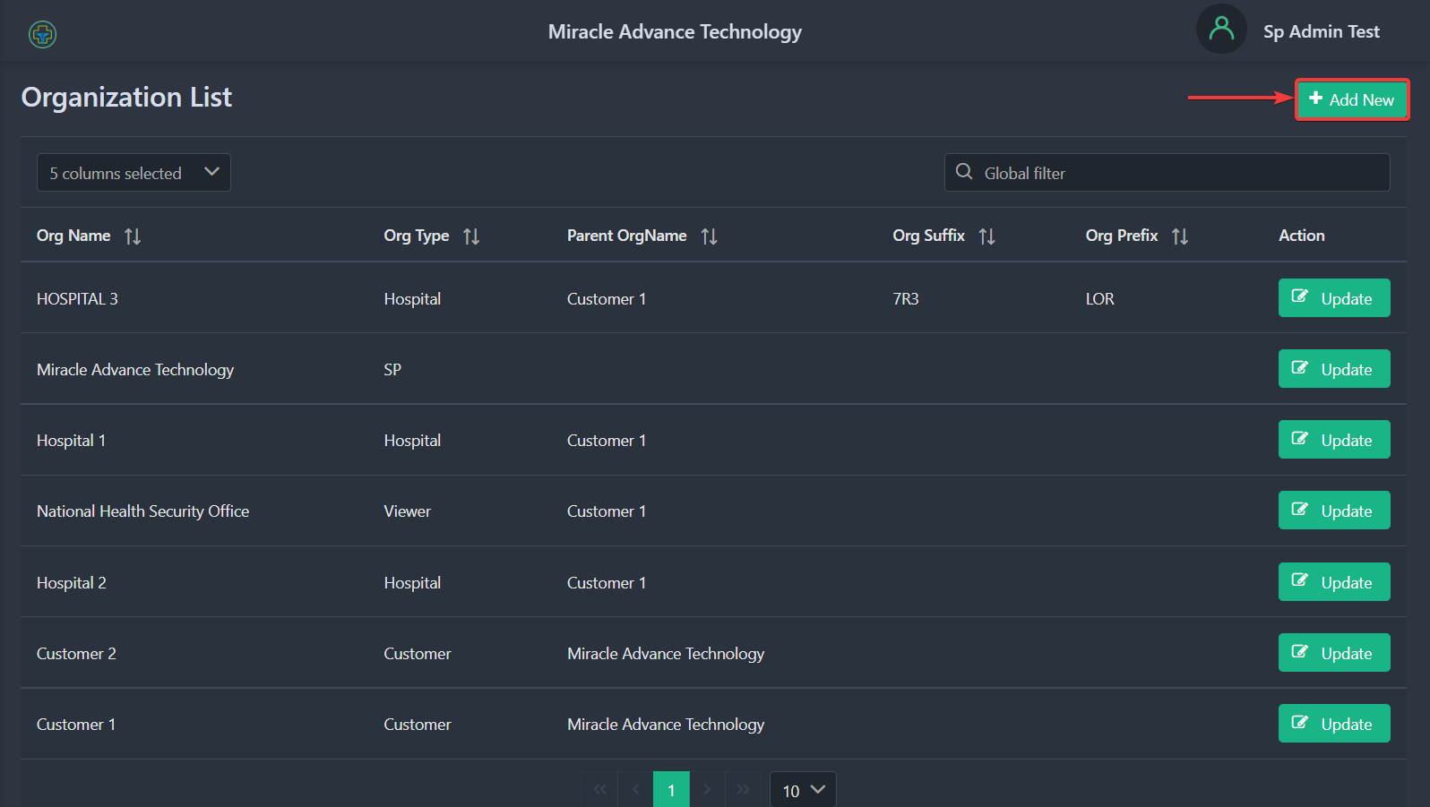

To add a new organization, you have to fill in 2 sections:
- General Information
- Organization Address

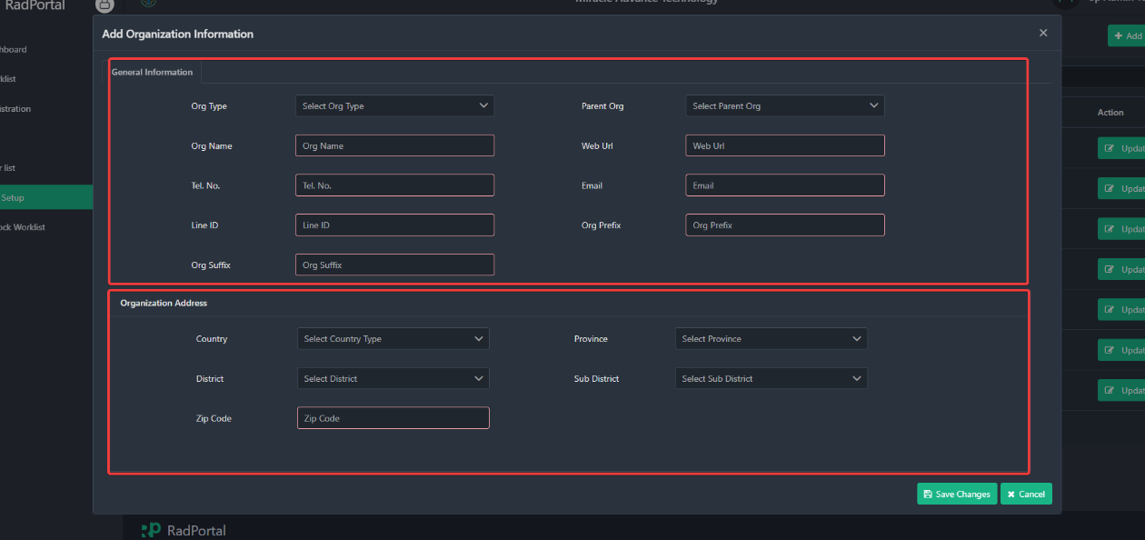
General Information:
To register an organization, you have to submit information such as the Organization Type [1], Parent Organization [2], Organization Name [3], Website URL [4], Telephone Number [5], Organization Email[6], Line ID [7], Organization Prefix [8], and Organization Suffix [9].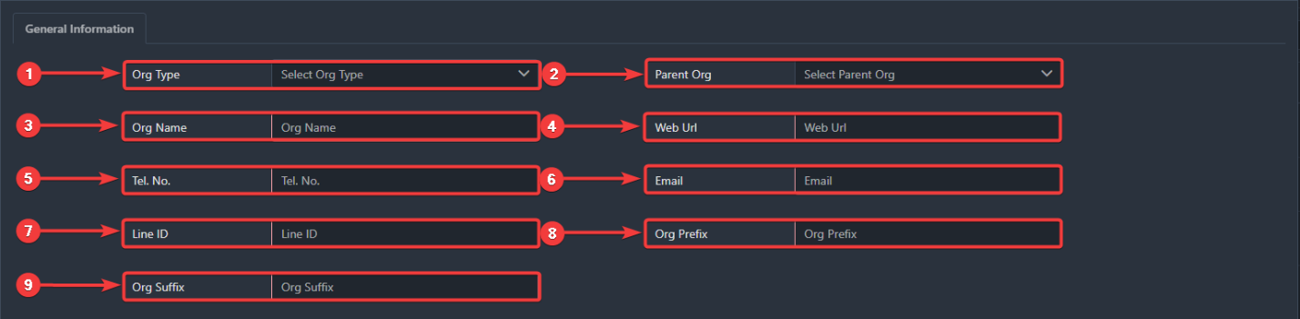

In the Organization Type role drop-down, you can choose organization types such as Customer[I], Hospital [II], or Viewer [III].
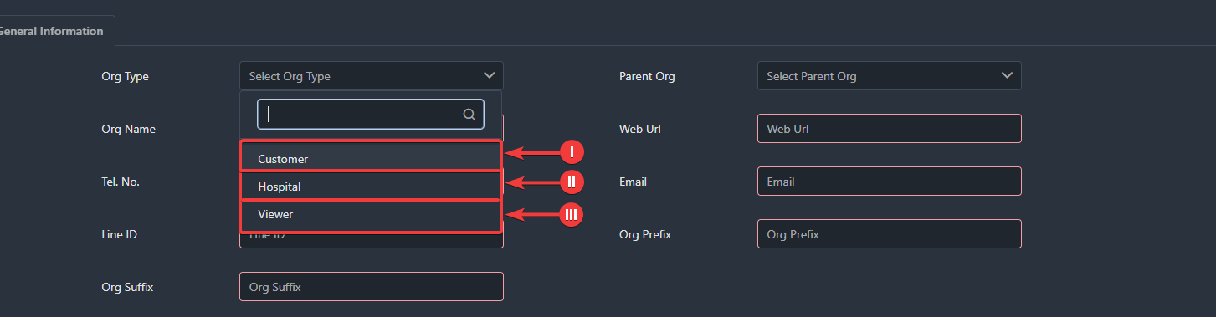

Organization Address
In the following Field, you have to fill in the Organization Address, such as Country Name [1], Province [2], District [3], Sub District [4], and Zip Code [5].
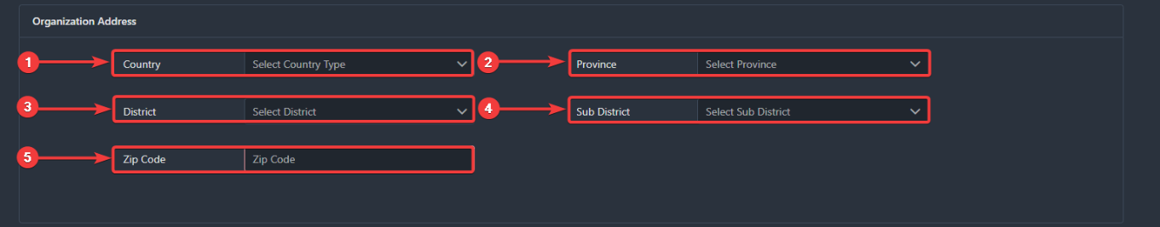

Finally, click on the Save [1] button to save or click on Cancel [2] to go back to the Organization management page.
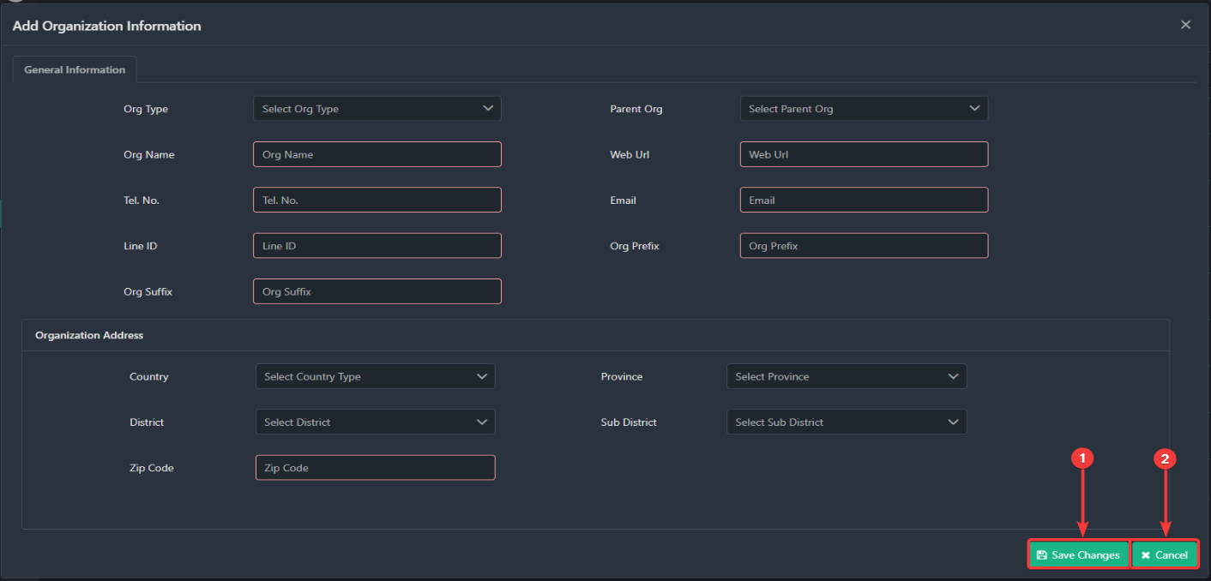

7.2 How to Update Organization Information
You can approve the users you just created. You can also edit or update your user's information by clicking on the Update button.
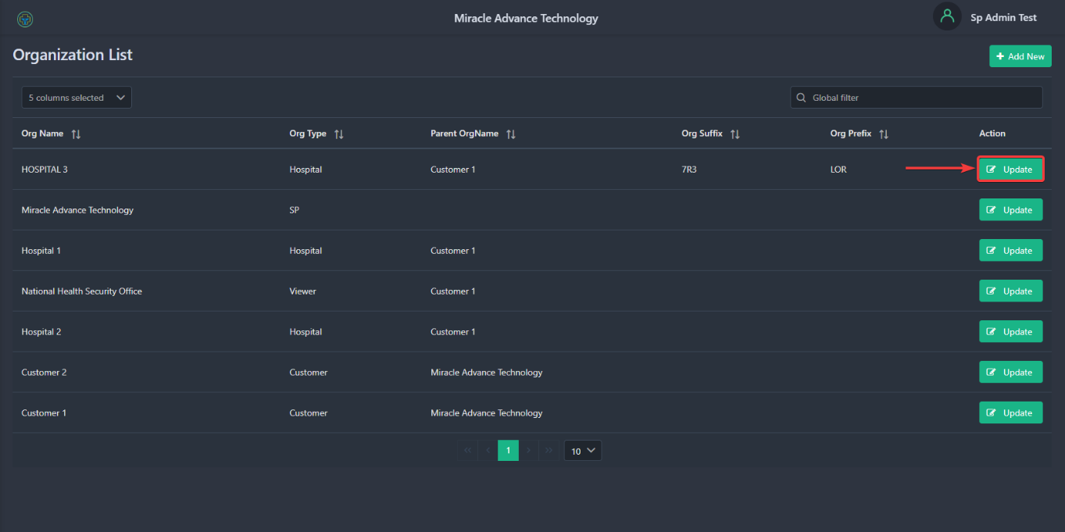

After clicking on the Update, you should see a new popup window where you can update organization information.
